Aia Al-Qasab

T5616SN

Advanced Enterprise Server Environment

Lab 3

**Virtualization Lab 3. Hyper-V Failover Clustering**

February 2019



**Virtualization Lab 3. Hyper-V Failover Clustering**

**Step 1. Prepare the Servers and Configure Virtual Networking**

- Start **WinServer-DC** and **wait for the log in screen to appear** (no need to login yet).

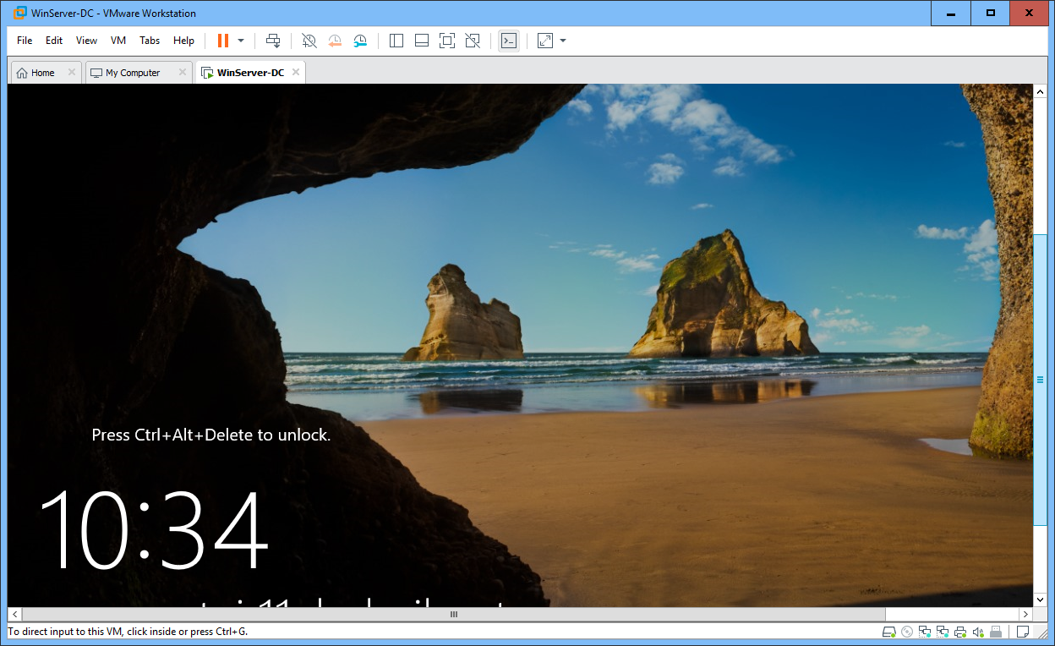

- Start **WinServer-01** and **WinServer-02**

- Log in to **WinServer-01** as **MAMKLAB\Administrator** / **P@ssw0rd** (not the local admin!)

o If the network is recognized as a new network, and you get a question “*Do you want to find PCs, …*”, select **YES**

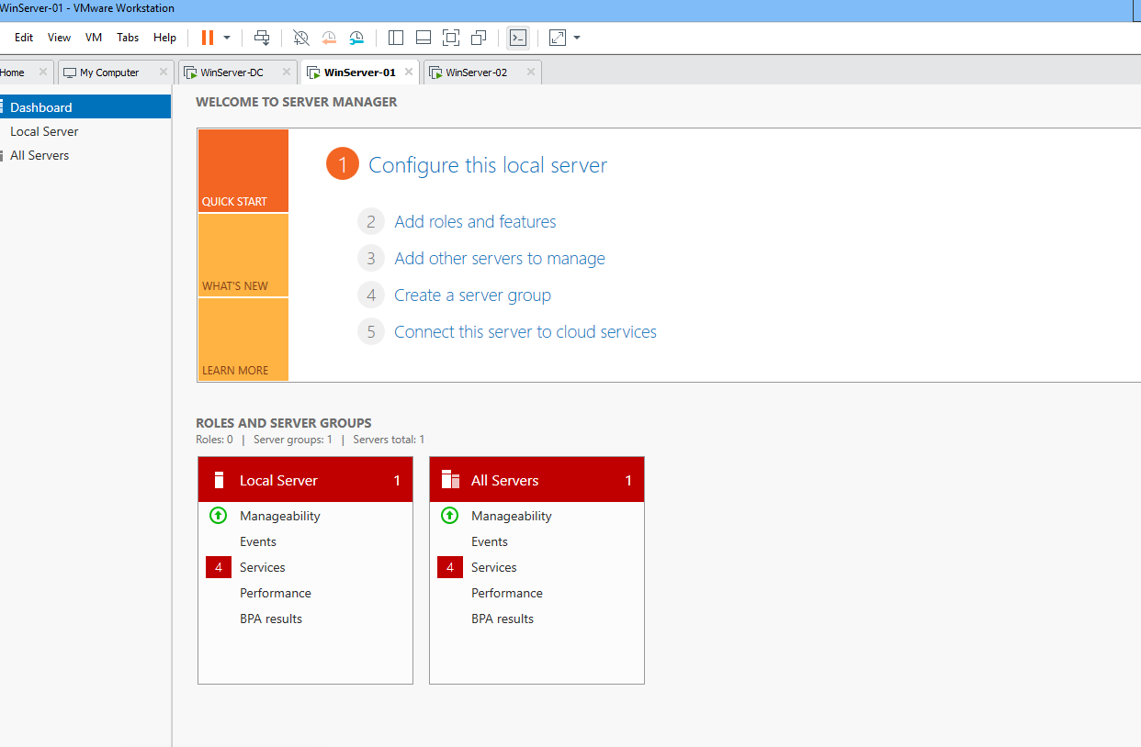

- Both servers already have the **Hyper-V** role installed

- Let’s practice configuring virtual networking in PowerShell

o Start **PowerShell** (or **PowerShell ISE**) in **WinServer-01**

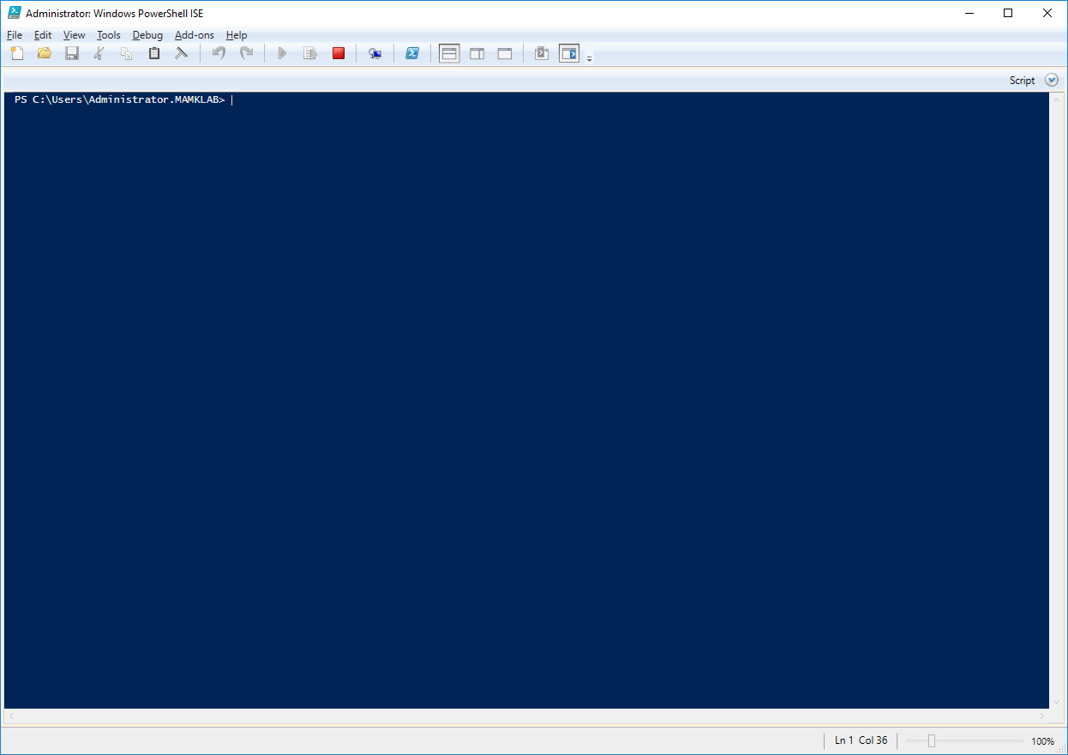

o Use the Get-NetAdapter cmdlet to display the current NICs.

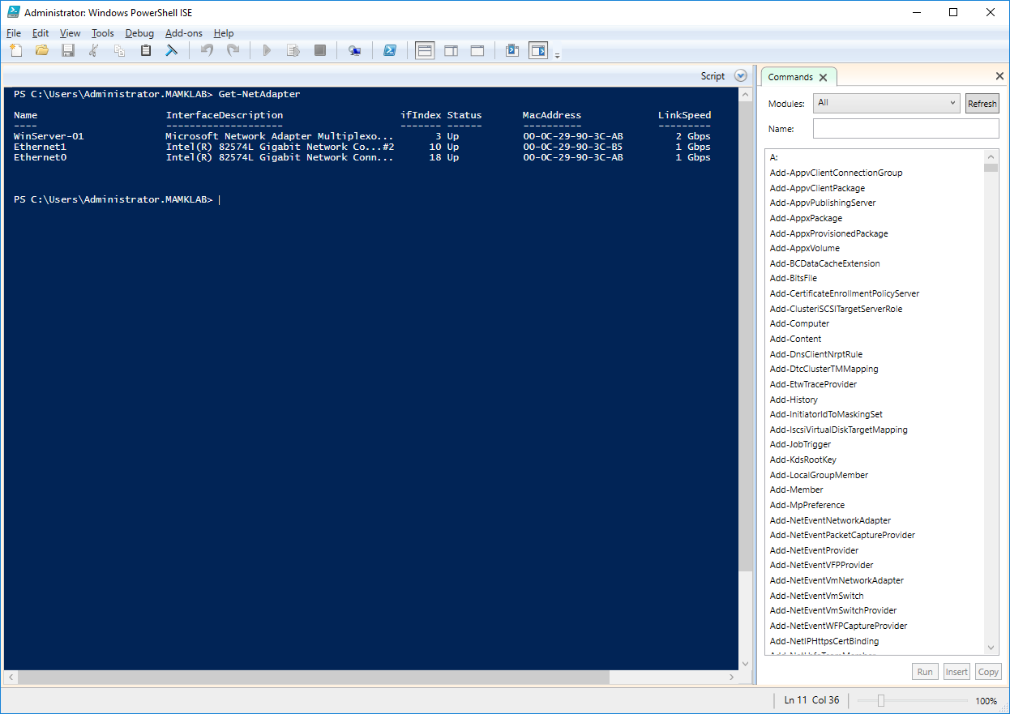

o In this case, you want to use the “**WinServer-01**” adapter (a teamed adapter with 2 Gbps link speed).

o Create a new **external virtual network switch** with the name **vSwitch**, using the “**WinServer-01**” NIC. Also allow the management OS (the WinServer-01’s operating system) to access the physical NIC: New-VMSwitch -Name vSwitch -NetAdapterName WinServer-01 -AllowManagementOS $true

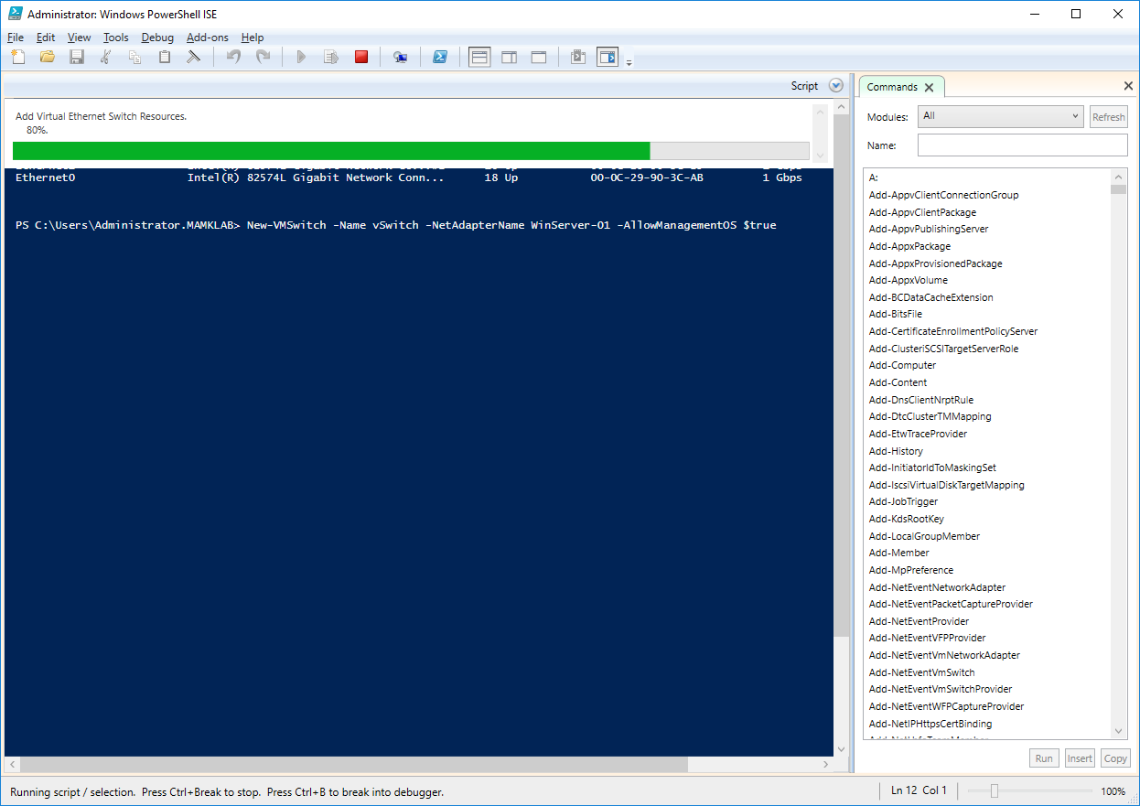

o Then, create the virtual switch also to **WinServer-02** (no need to login there, with PowerShell you can invoke commands in remote computers. So in WinServer-01, run a command: Invoke-Command -ComputerName WinServer-02 { New-VMSwitch -Name vSwitch -NetAdapterName WinServer-02 -AllowManagementOS $true } (Running the command takes some time as creating the virtual switch causes the remote server’s physical NIC to temporarily disconnect. Just wait patiently couple of minutes and the result should be successful).

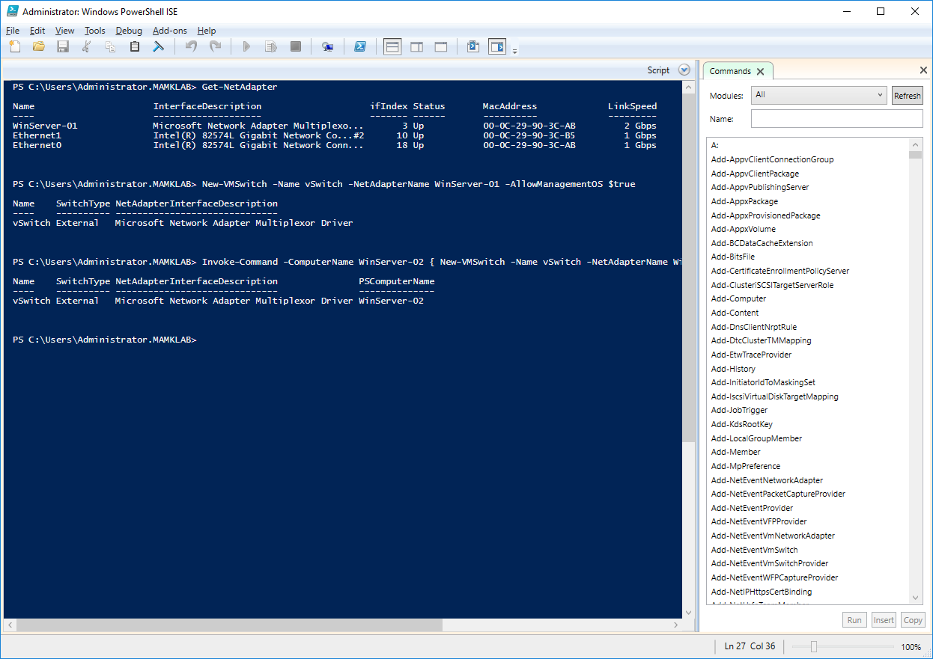

o Check that you now have the new vSwitch on both **WinServer-01** and **WinServer-02**: list the network adapters from **both** servers with the command: Invoke-Command -ComputerName WinServer-01, WinServer-02 { Get-NetAdapter } | Format-Table

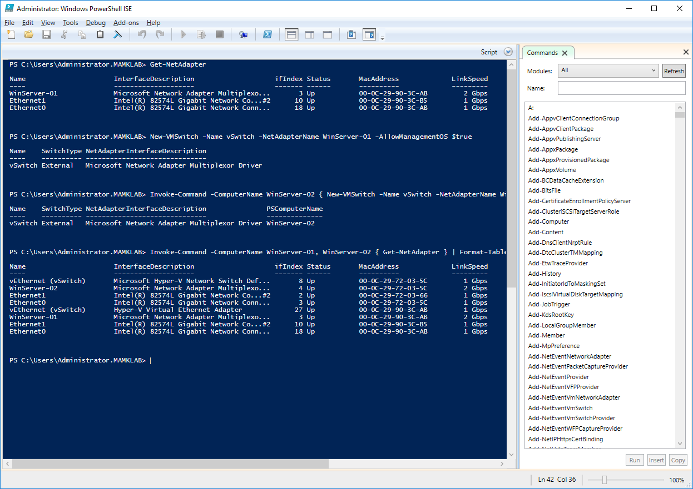

**Step 2. Prepare Shared Storage for Failover Clustering**

- In a cluster, you must use a shared storage that is accessible by all cluster members.

o *In* ***your report****, explain why you need shared storage (why you cannot just use the local storage from each server).*

**A: Shared storage is a single storage resource pool that is shared by multiple computer server resources, it allows servers to save data and files on a shared storage system. It designed to be much faster, more reliable and easier to scale.**

- Login to **WinServer-DC** as **MAMKLAB\Administrator** / **P@ssw0rd**

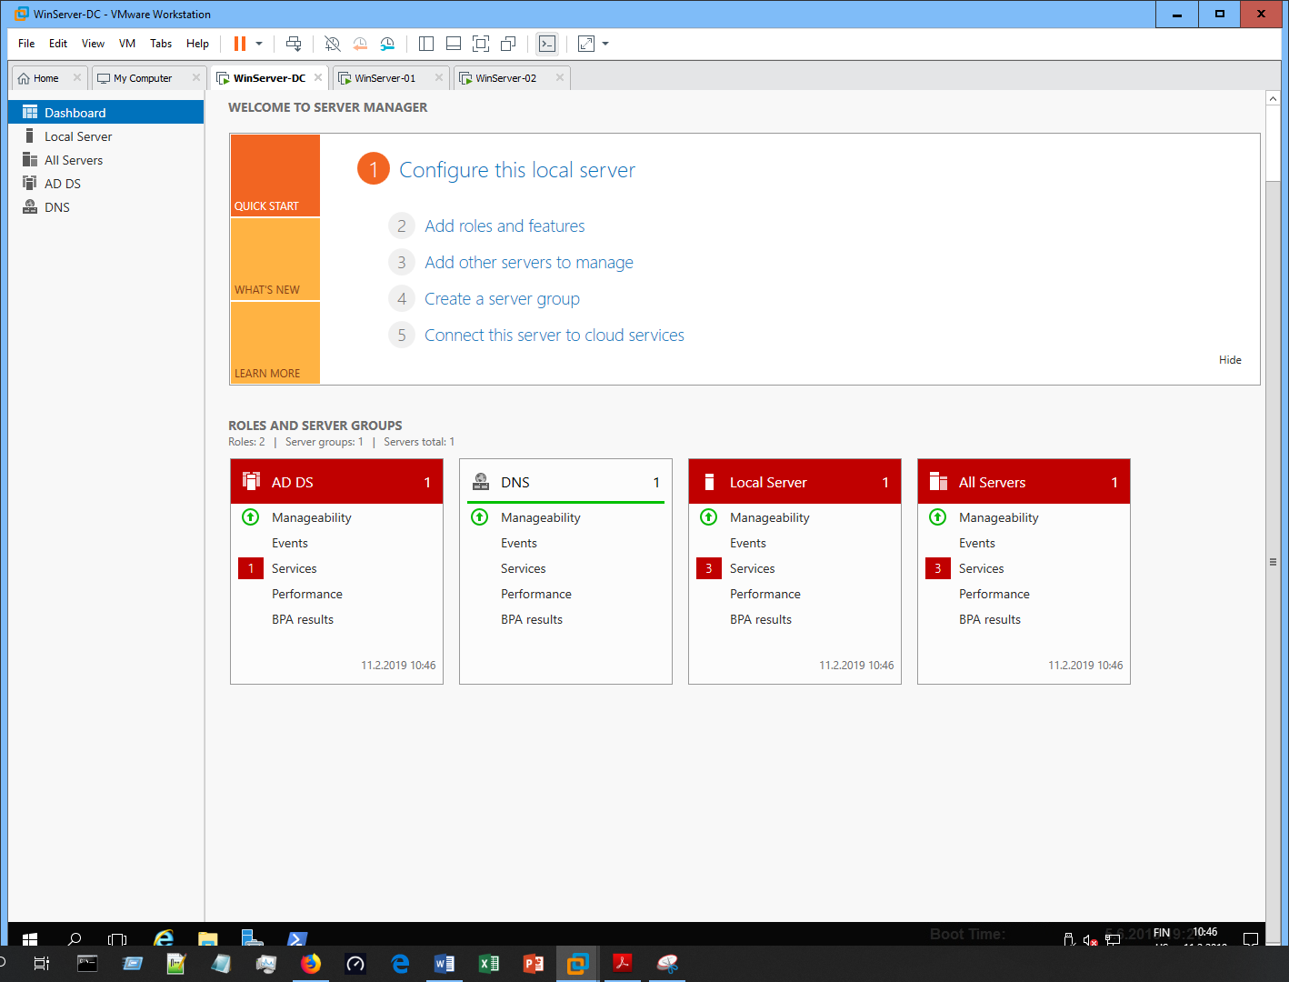

- Start **Server Manager**, go to **File and Storage Services** → **iSCSI**

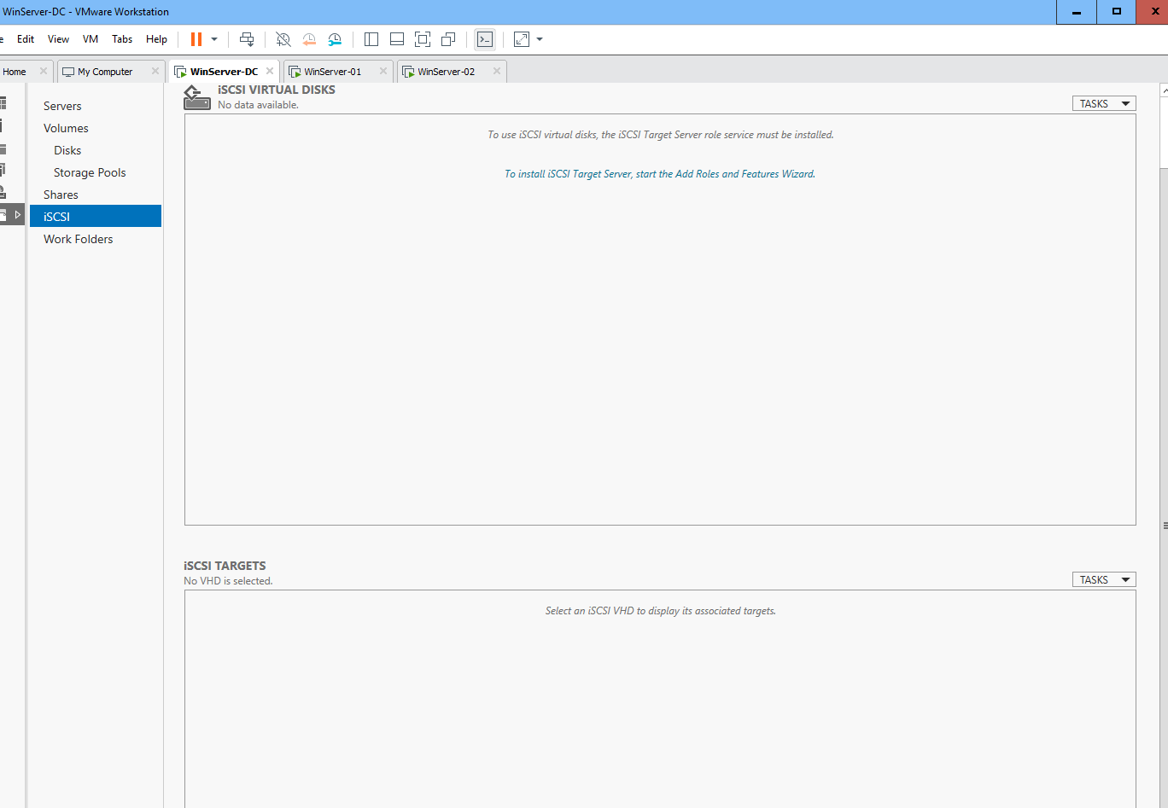

- Install the **iSCSI Target Server** role service (click the link “To install iSCSI Target Server…”) with the default settings

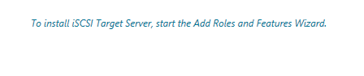

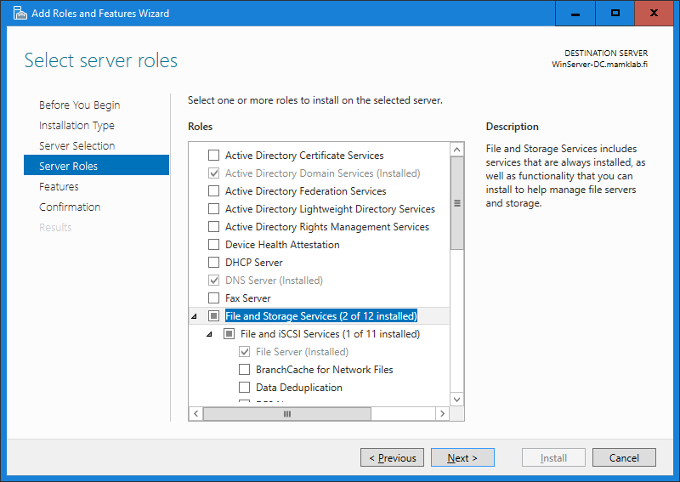

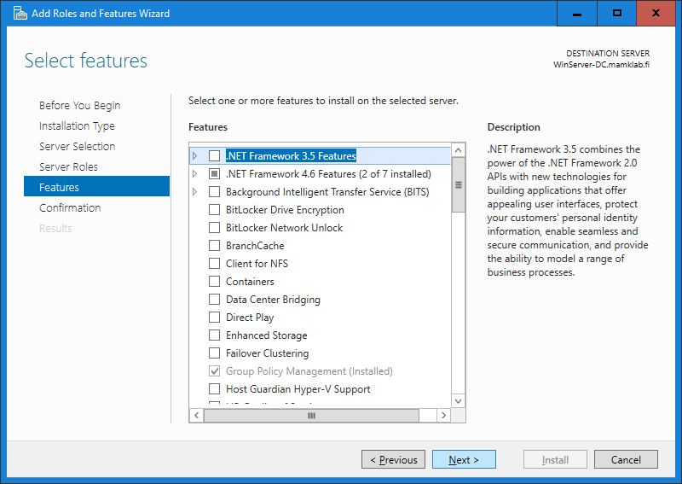

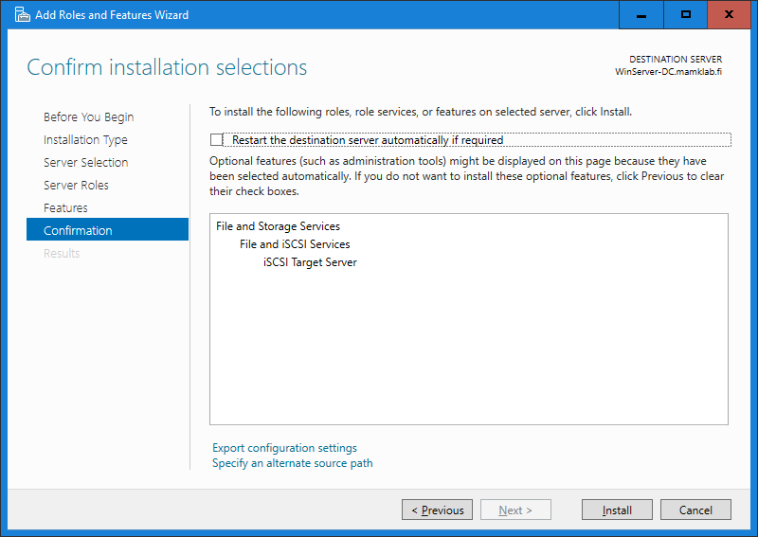

- Create two new iSCSI virtual disks with the following configurations:

o Disk 1: Name: **ClusterVMs**, size: **20 GB** (dynamically expanding)

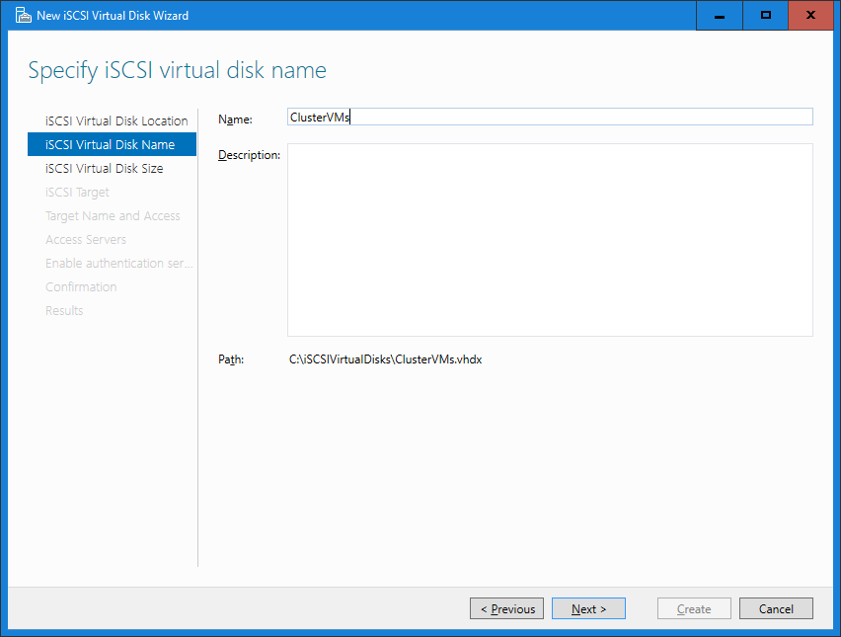

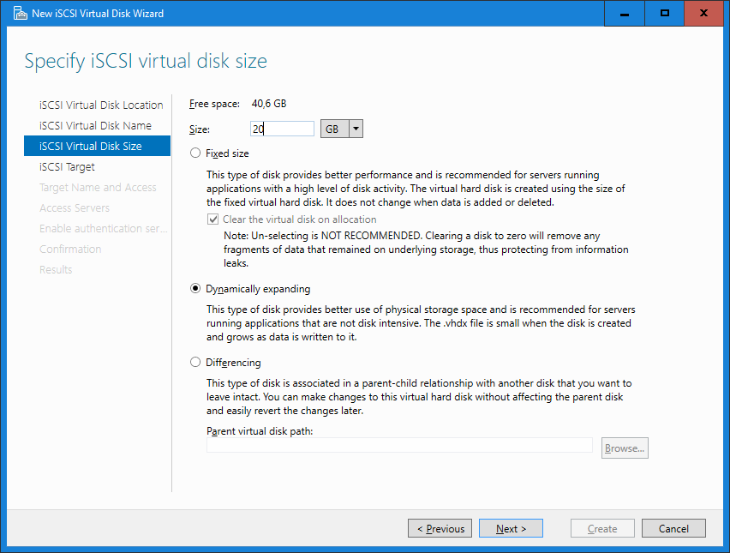

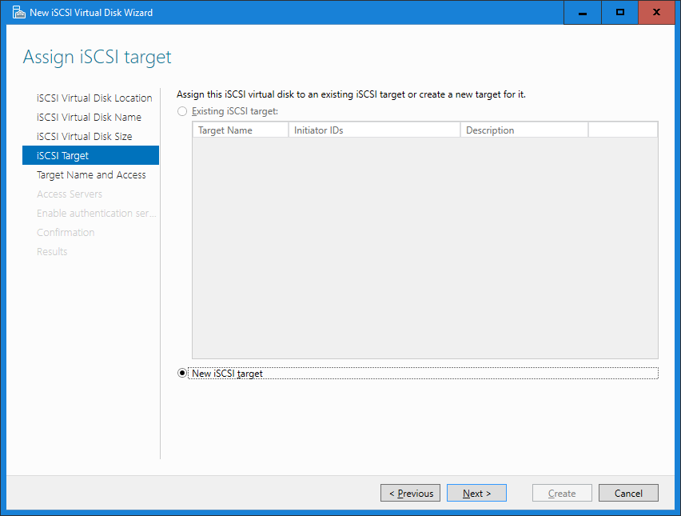

▪ Also create a new iSCSI target: Name: **WinServer-DC**, Access- Servers: **IQN: \*** (accept everyone)

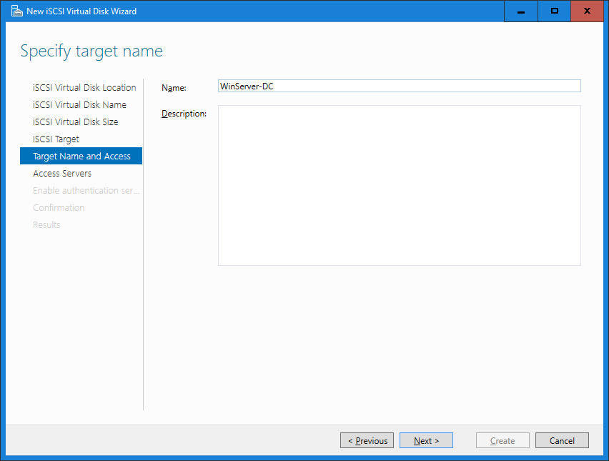

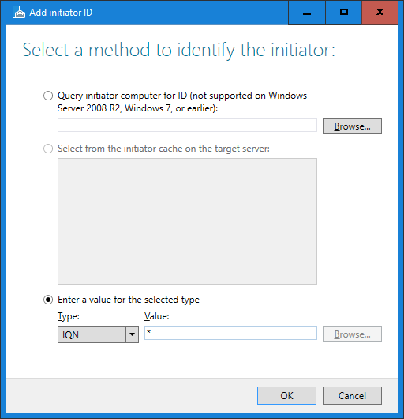

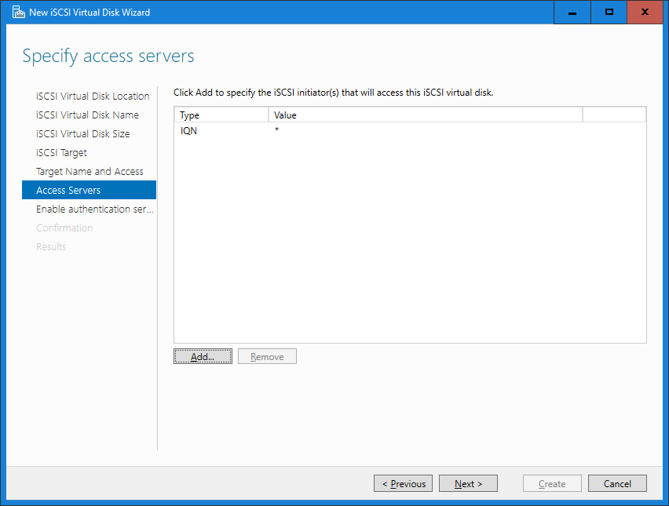

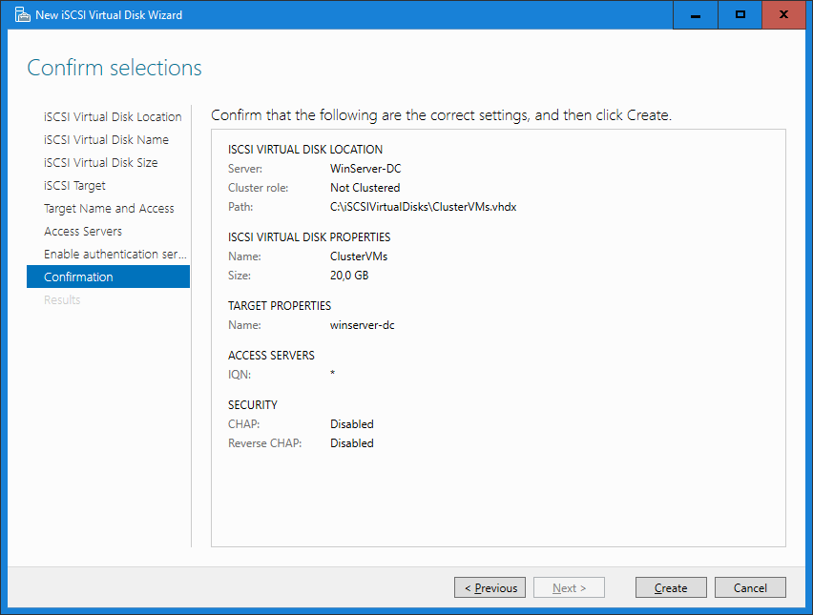

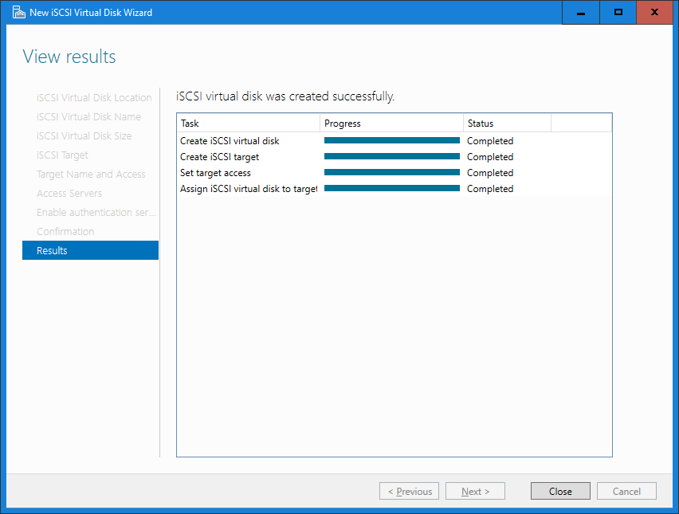

o Disk 2: Name: **ClusterQuorum**, size: **1 GB** (dynamically expanding)

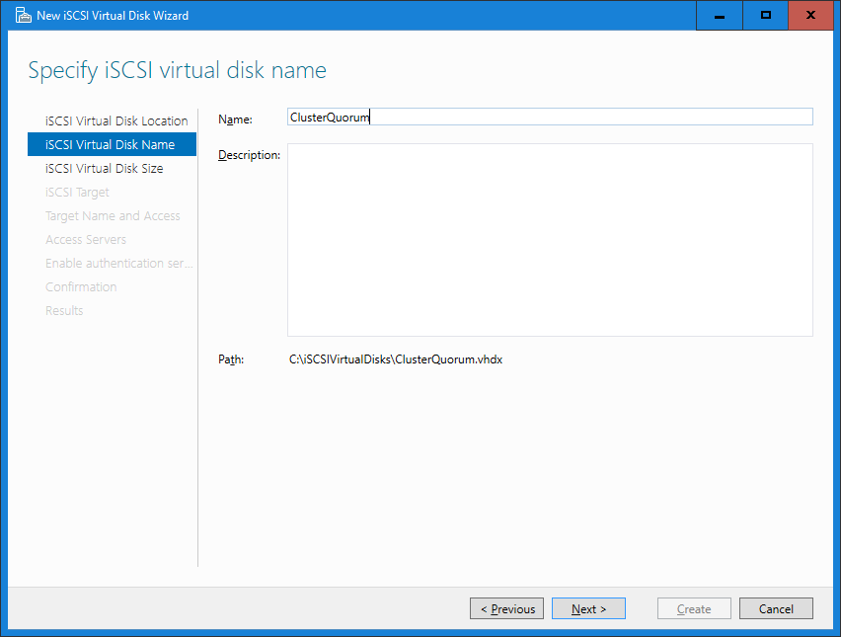

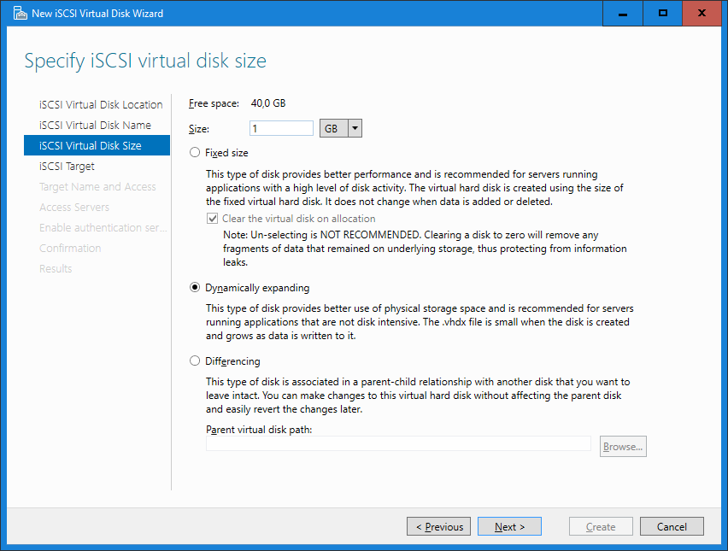

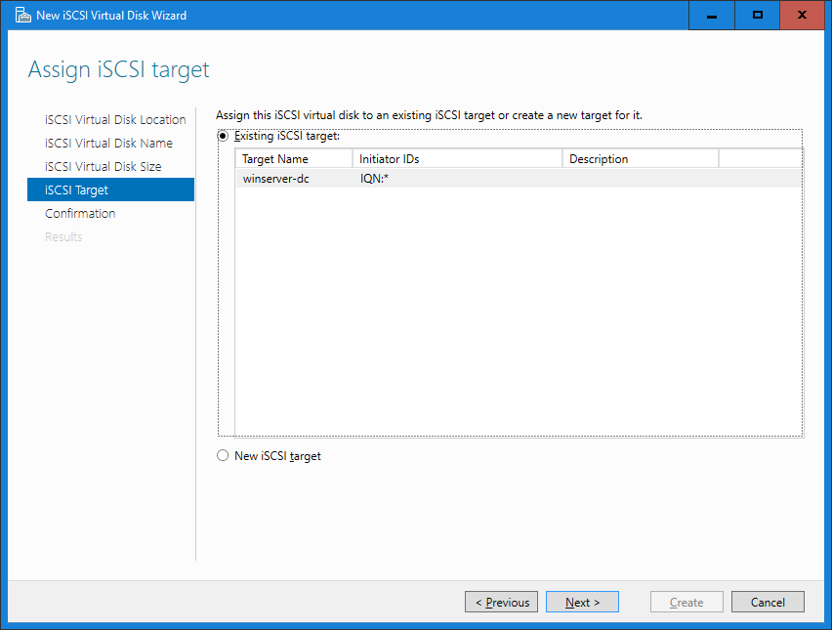

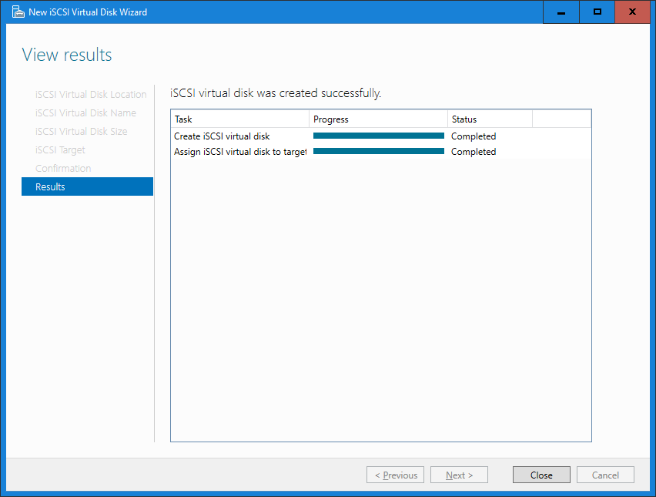

- Now the shared storage is configured and waiting to be taken into use.

**Step 3. Configure the Storage in the Failover Clustering Nodes**

- Log in to **WinServer-02** as **MAMKLAB\Administrator** / **P@ssw0rd** (not the local admin!)

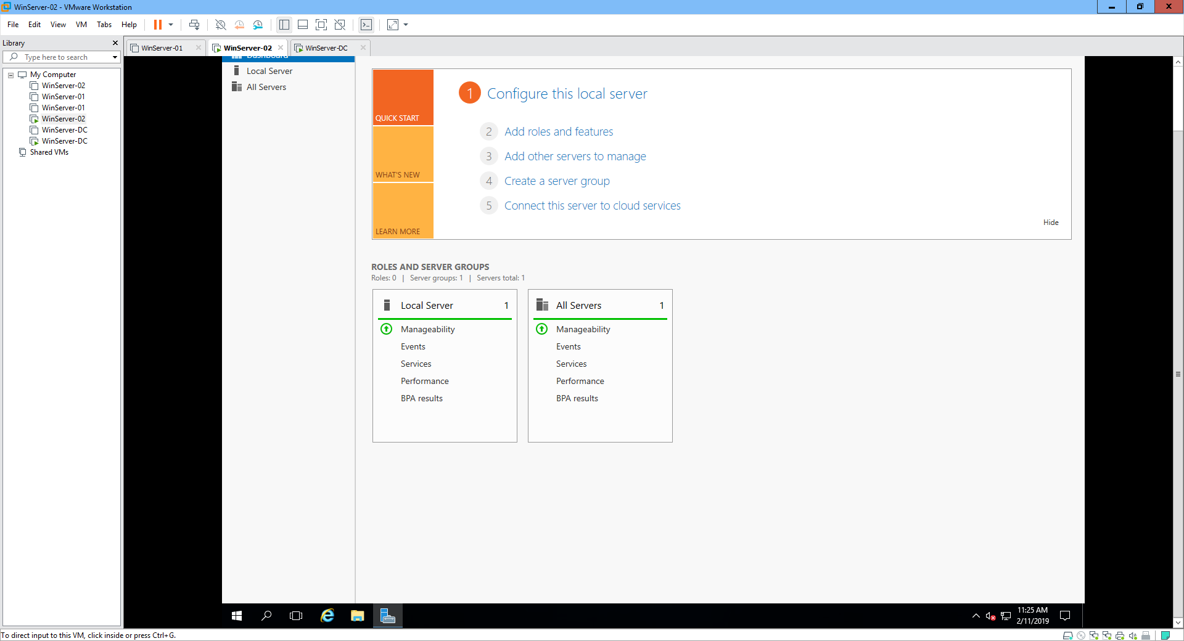

- Start the **iSCSI initiator** and connect to the iSCSI target on **WinServer-DC**.

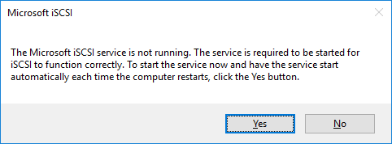

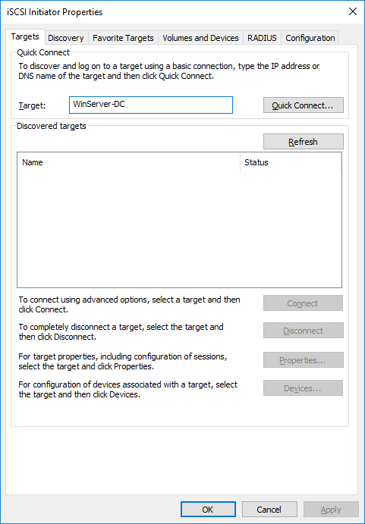

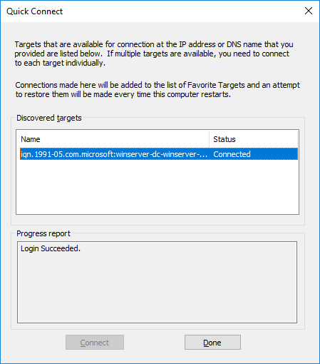

- Open **Disk Management** and **bring online** all iSCSI drives and **initialize** them.

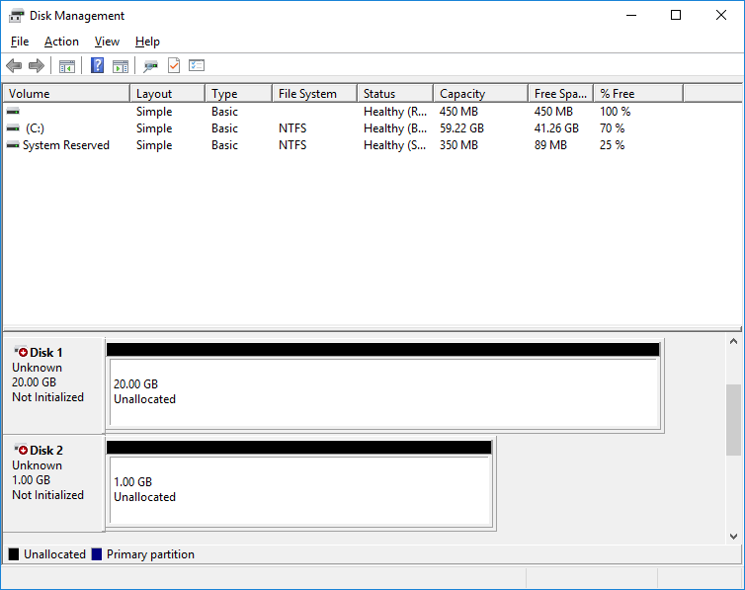

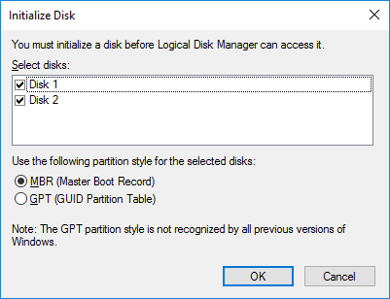

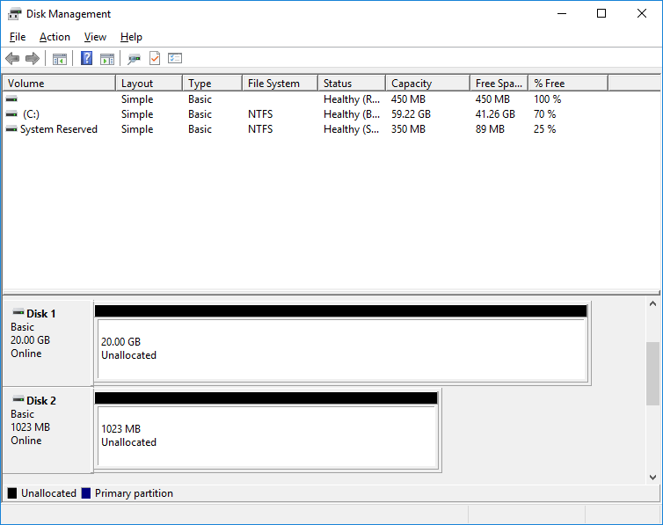

o Format the first drive (20 GB) and name the volume as **ClusterVMs**.

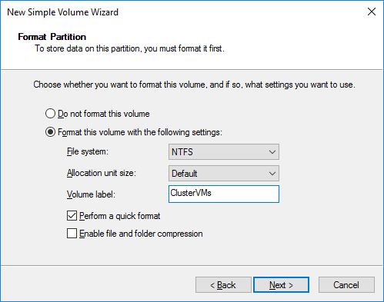

o Format the second drive (1 GB) and name the volume as **ClusterQuorum**.

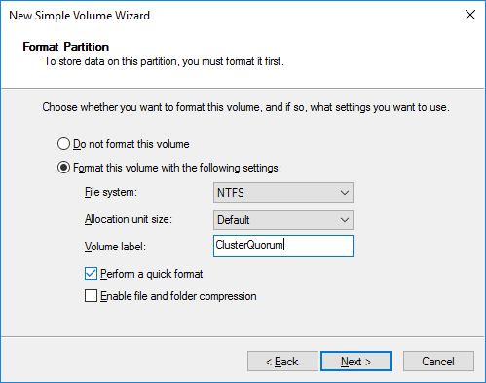

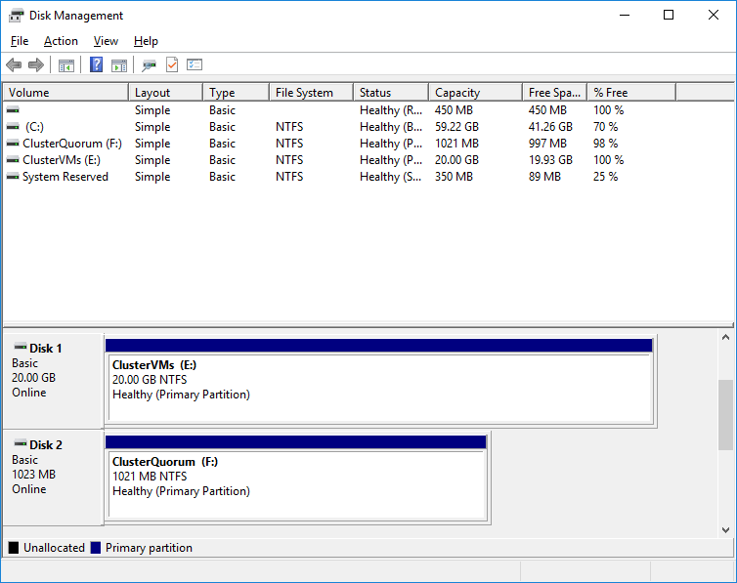

- Also connect to the iSCSI target on **WinServer-01**, then open **Disk Management** and **bring online** both iSCSI drives.



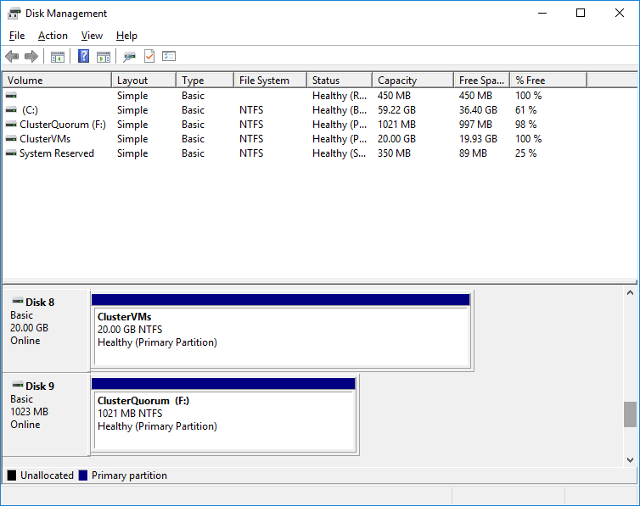

- Now you have access to the same shared storage from both **WinServer-01** and **WinServer-02**

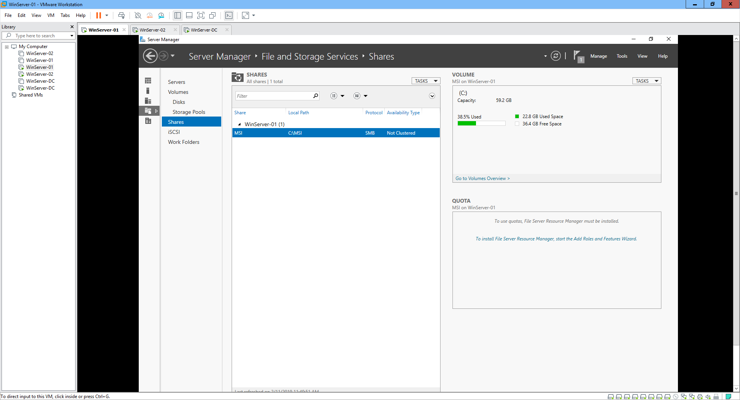

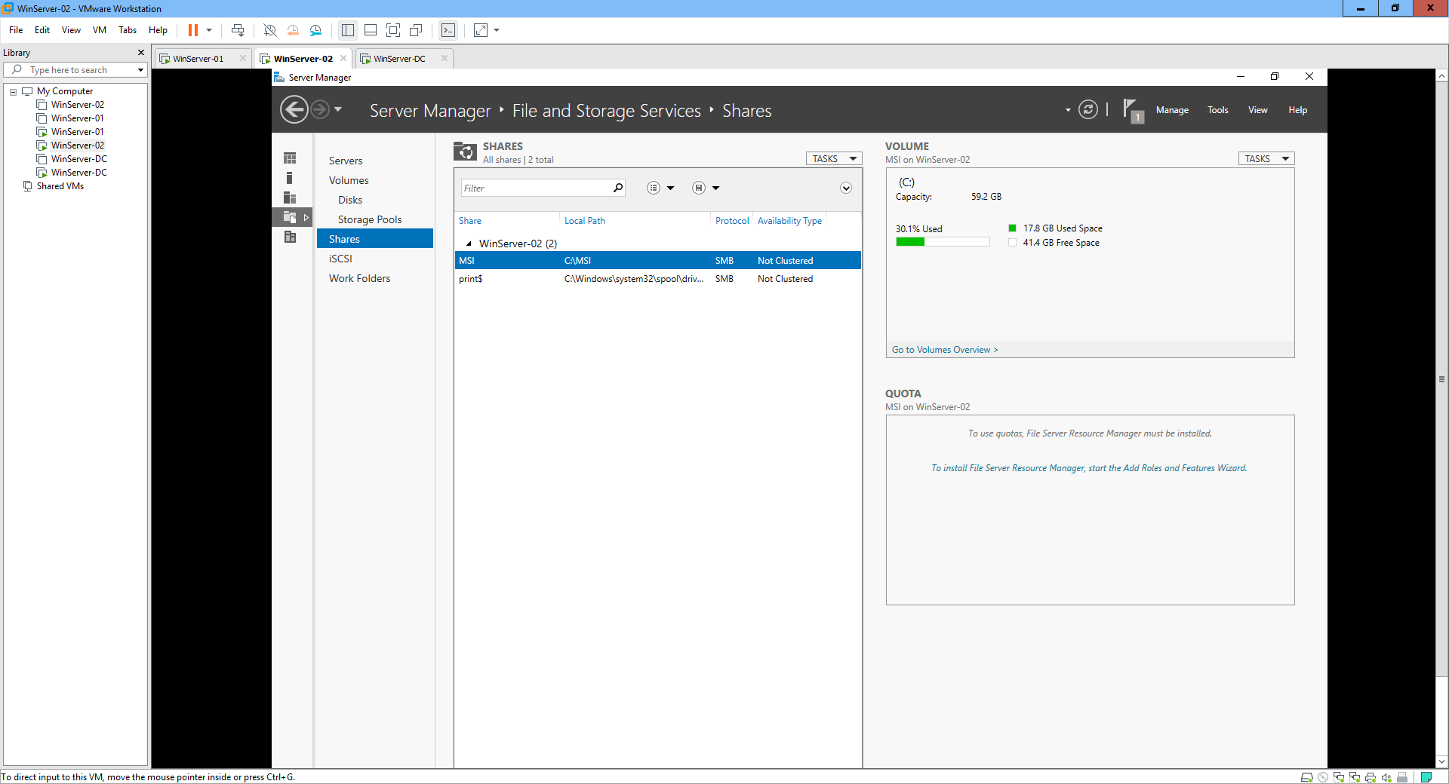

**Step 4. Configure the Failover Clustering**

- On **WinServer-01**, install the **failover clustering** feature and the management tools with **PowerShell** to **both** servers:

o Invoke-Command -Computername WinServer-01, WinServer-02 -command { Install-WindowsFeature -Name Failover-Clustering –IncludeManagementTools }

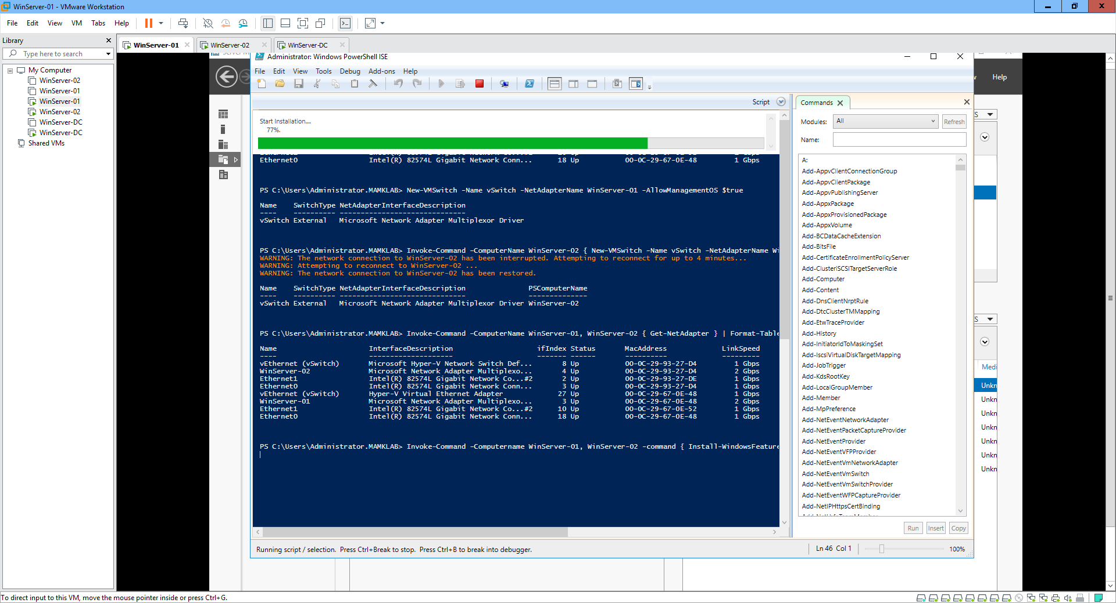

o You should get an **ExitCode** of **Success** from both servers.

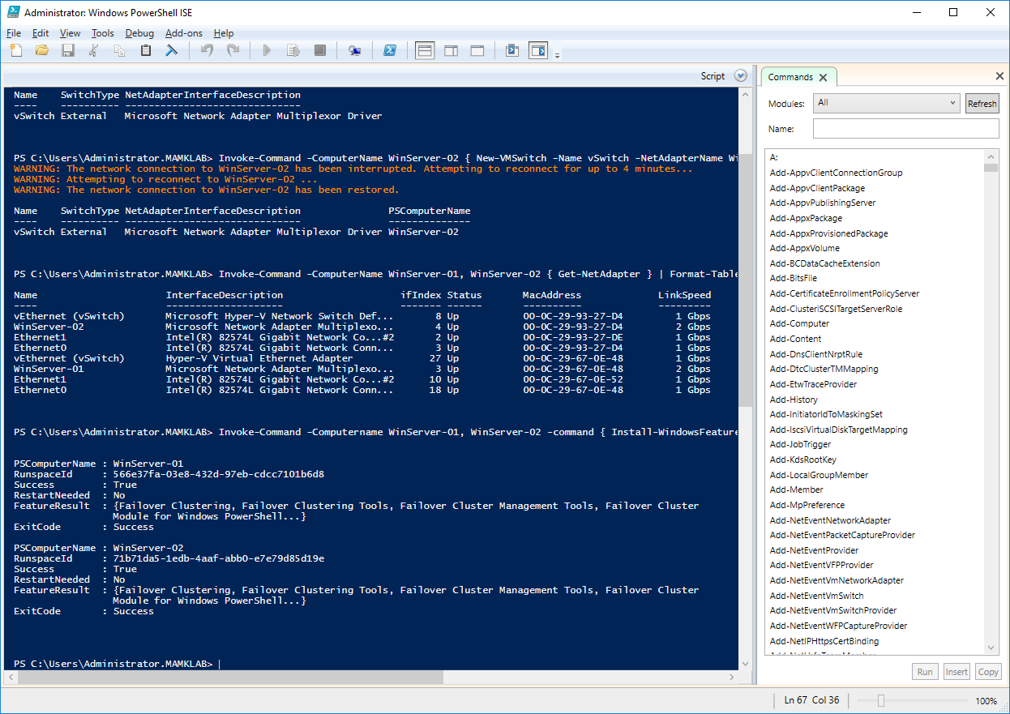

o Also ensure that the failover clustering feature and the management tools are installed:

* Get-WindowsFeature Failover*

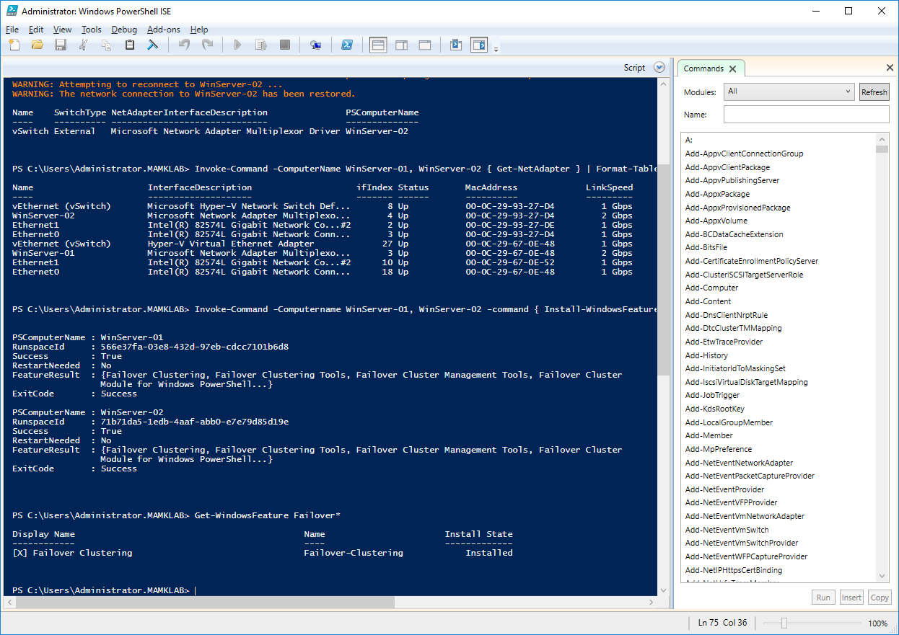

* Get-WindowsFeature RSAT-Cluster*

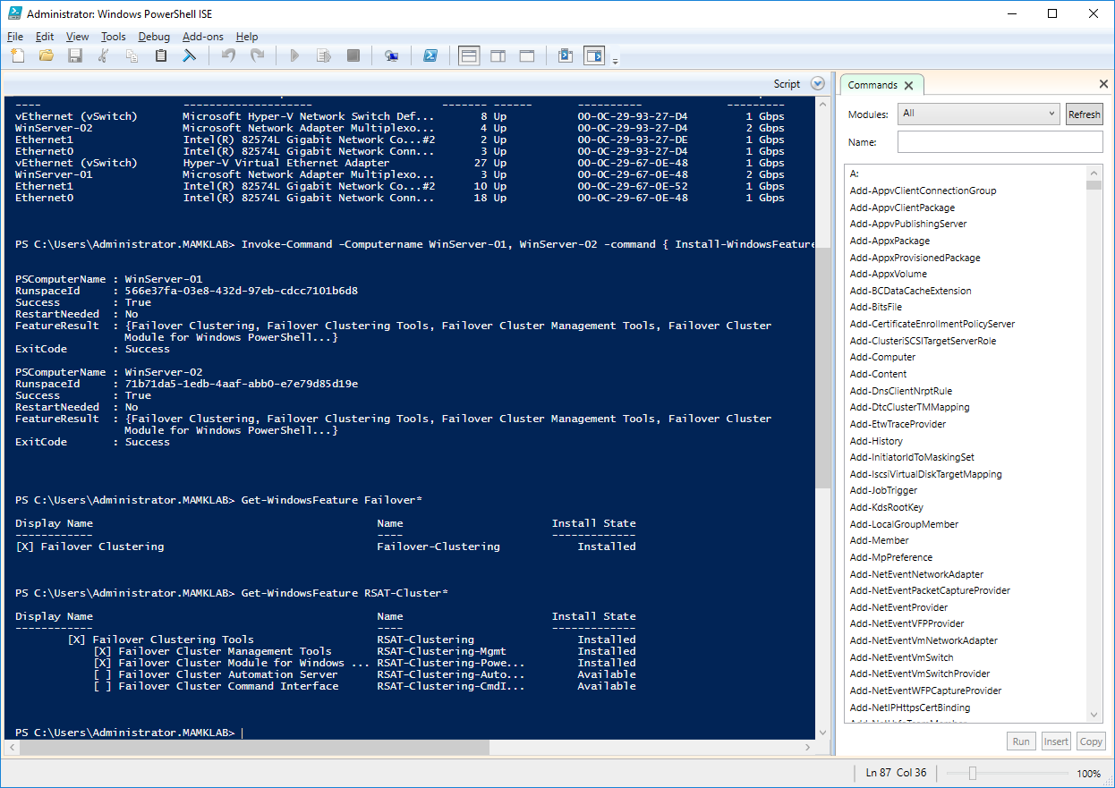

- Run **validation tests** for failover cluster hardware and settings to check that the servers are ready for cluster configuration.

o Test-Cluster -Node WinServer-01, WinServer-02 (running the test takes about 5-10 min)

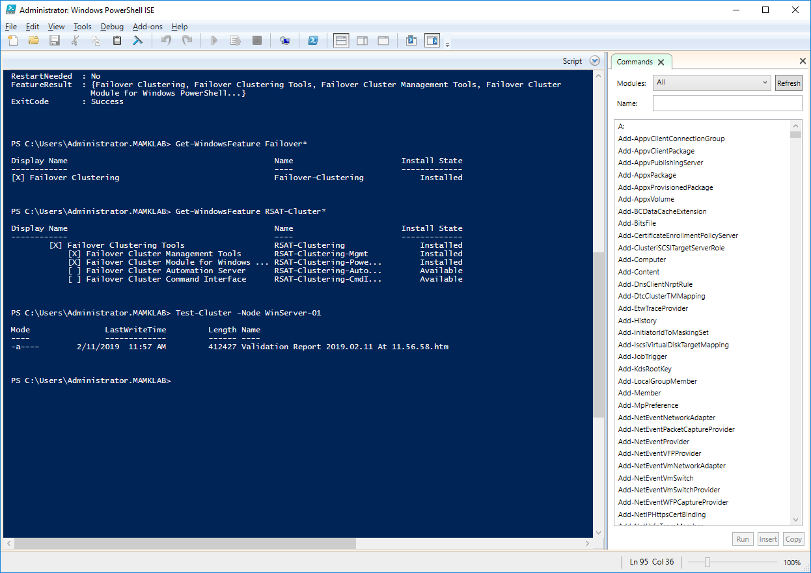

o Open and review the report file: C:\Windows\Cluster\Reports\Validation Report 20XX.XX.XX At YY.YY.YY.xml.mht

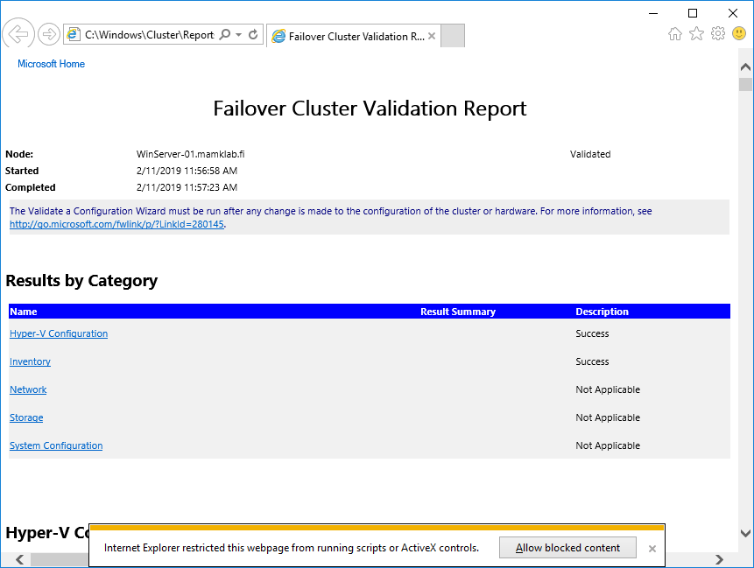

o Both nodes (WinServer-01 and WinServer-02) should be **successfully** validated, but there are **warnings** about some configurations. Warnings don’t prevent creating a cluster but they may show some weaknesses or potential bottlenecks in the configuration. *Explore the warnings and explain them in* ***your report****.*

A: The warnings are because the cluster was already installed and had Isci initiators configured, it interrupted the Validation and some times it’s cause of the connectivity.

- Let’s change to the graphical tools to also practice using them. Open **Failover Cluster Manager** in **WinServer-01** and create a new cluster:

o Select both **WinServer-01** and **WinServer-02**

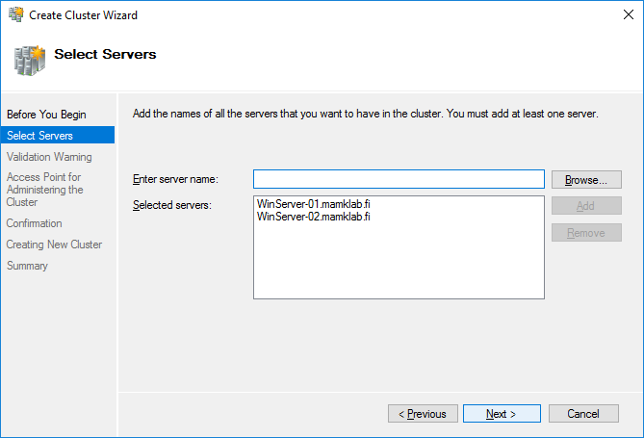

o Cluster Name: **VMCluster**

o Assign the cluster an IP address 192.168.163.111

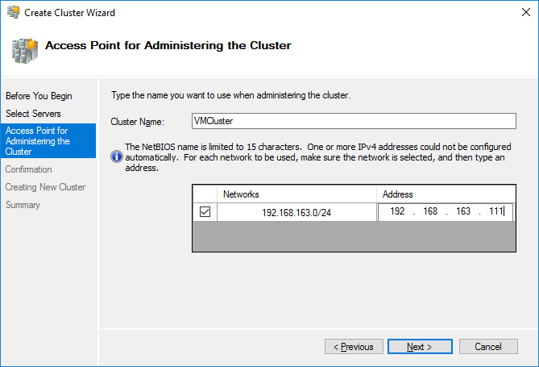

o **Deselect** the option to Add all eligible storage to the cluster

- Then, configure the disks for the failover cluster

o In **Failover Cluster Manager**, add the two iSCSI disks to the cluster.

▪ Verify that both iSCSI disks appear available for cluster storage.

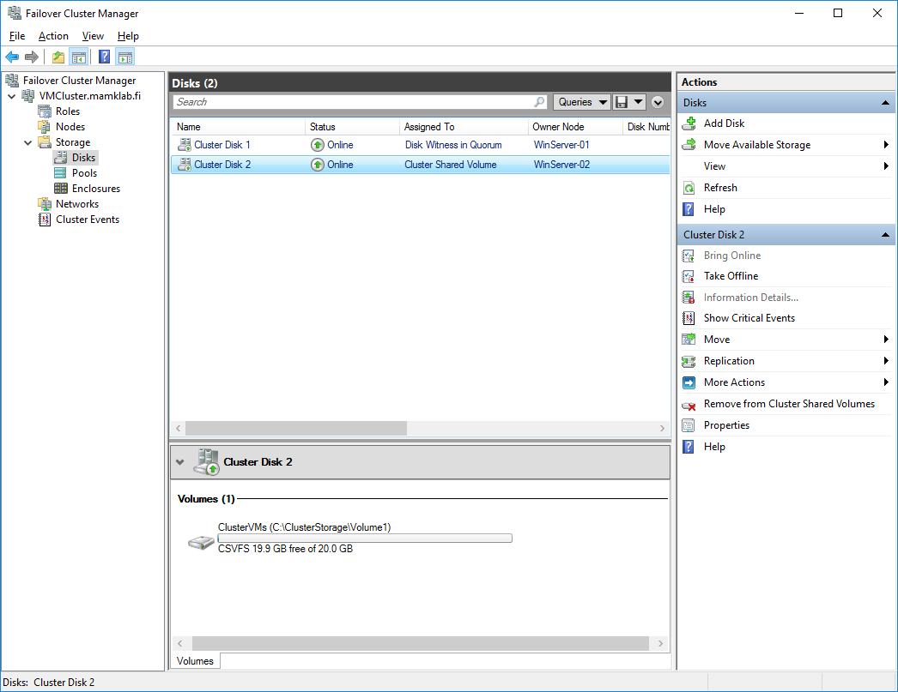

o *In* ***your report****, explain what a cluster shared volume is. How is it different to configure a cluster with a shared volume compared to using ordinary disks (LUNs used over the SAN)?*

A: **It is a feature in Windows Server in which shared disks are concurrently accessible to all nodes within a failover cluster. One node could access the data at any time to avoid corruption of the data on the LUN, if you had multiple nodes writing data to that same disk at the same time you would risk corruption. When one node owned a disk, it would place a reservation on that volume. If another node tried to access this disk, it would ask for ownership of the PR, which would either be granted or denied by the node which currently owned the reservation. If another node was given ownership of the PR, the physical disk resource would fail over to that node and that node would begin managing access to the LUN.**

o From the **VMCluster.mamklab.fi** node, select **More Actions** and then configure the **Cluster Quorum Settings** to use the default settings.

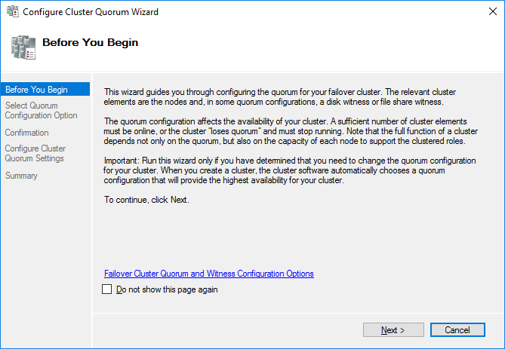

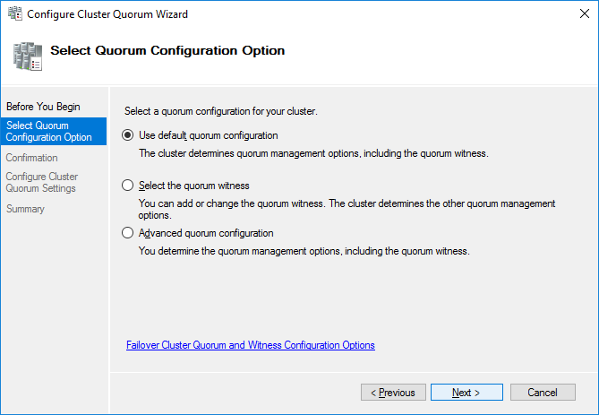

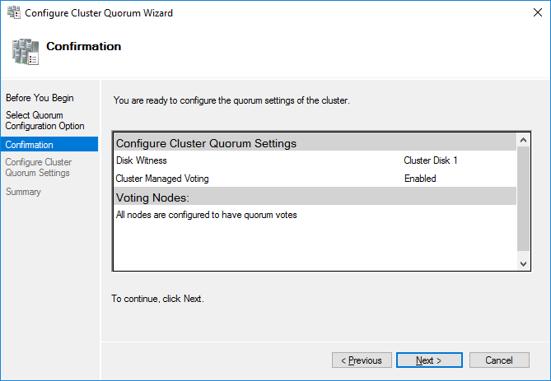

o On the summary page, view the report and investigate the quorum configuration.

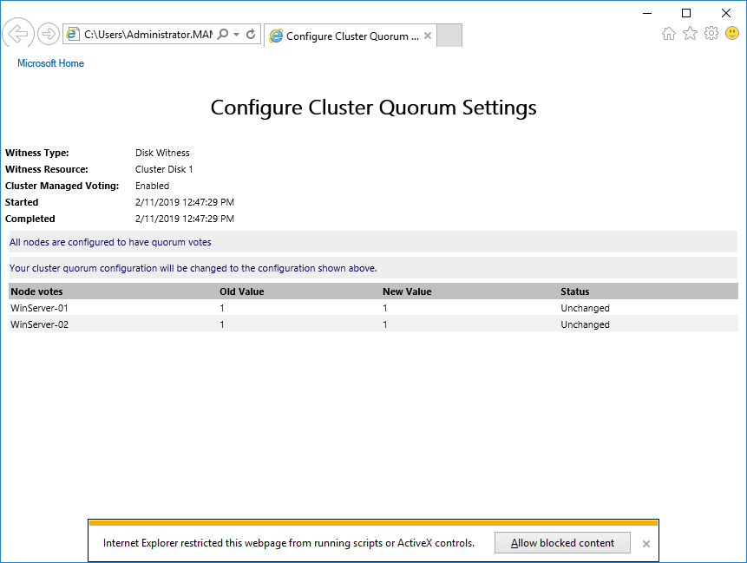

o *Questions: What is the role of the quorum configuration in a cluster (=why is the quorum needed in a cluster)?*

A: A cluster quorum disk is the storage medium on which the configuration database is stored for a cluster computing network, the cluster configuration database also called the quorum, it tells the cluster which physical servers should be active at any given time. The quorum disk comprises a shared block device that allows concurrent read/write access by all nodes in a cluster.

**Step 5. Configuring a Highly Available Virtual Machine**

- Now that you have a working cluster, you can add virtual machines as Highly Available resources.

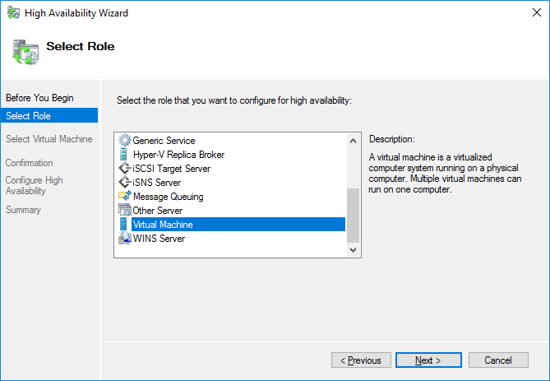

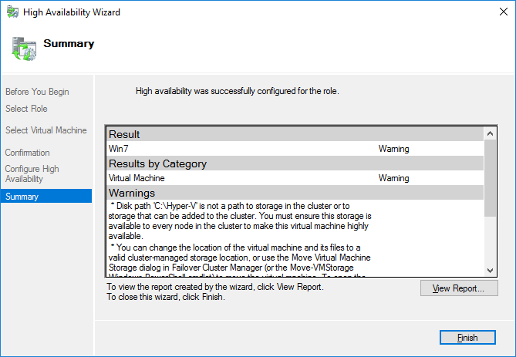

- Make sure that **WinServer-01** is the owner of the **ClusterVMs** disk.

o If it is not, move the **ClusterVMs** disk to **WinServer-01**.

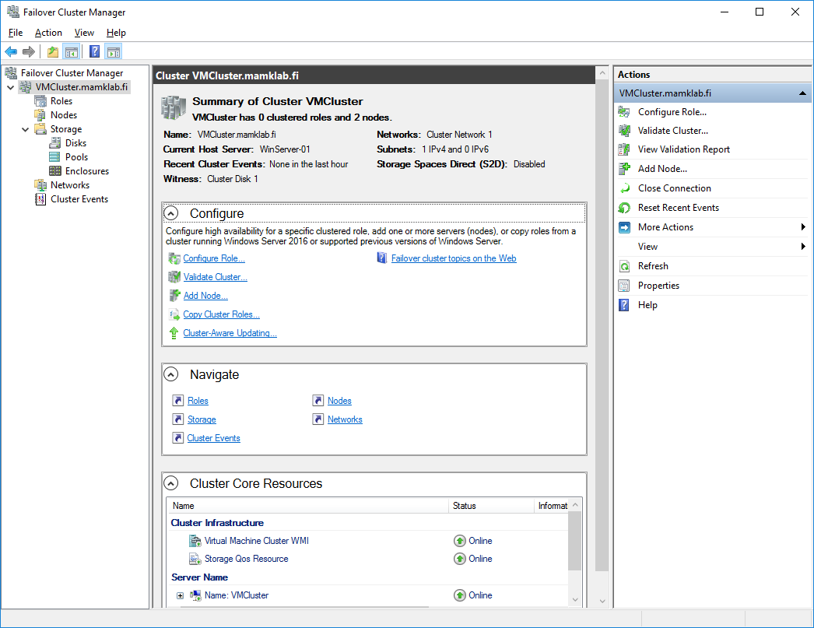

- Open Windows **File Explorer** and unzip the Win7-vhdx.zip file from P:\Matti\Hyper-V Images to C:\ClusterStorage\Volume1\ClusterVM. (use the **Student** / **student** account, if prompted for authentication)

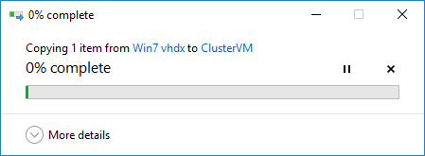

o The file includes a pre-installed Windows 7 VM.

o In case you have trouble connecting to the P-drive, you can use the server’s name (mb3) or it’s IP (172.16.1.30).

- In **Failover Cluster Manager**, click the **Roles** node, and then start the **New Virtual Machine wizard**.

In **Failover Cluster Manager**, click the **Roles** node, and then start the **New Virtual Machine wizard**.

o Select **WinServer-02** as the target cluster node.

o Name **ClusterVM**

o Location C:\ClusterStorage\Volume1\ClusterVM

o Specify Generation **Generation 1**

o Startup Memory 512MB

o Connection **vSwitch**

o Use existing vhd C:\ClusterStorage\Volume1\ClusterVM\Win7.vhdx

o Review the report

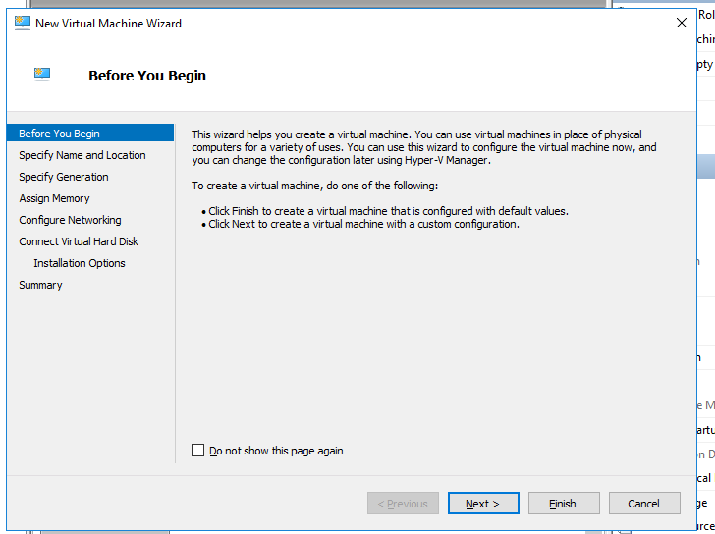

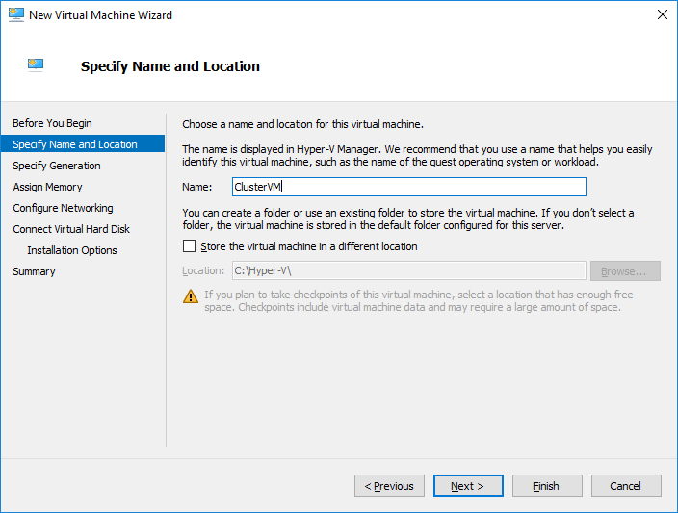

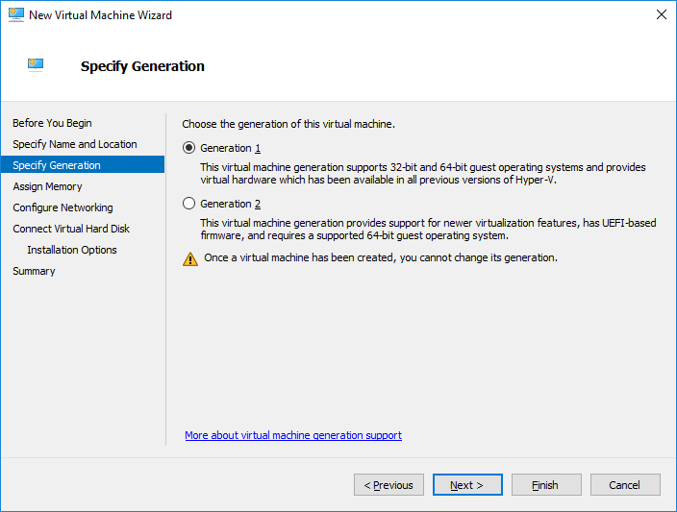

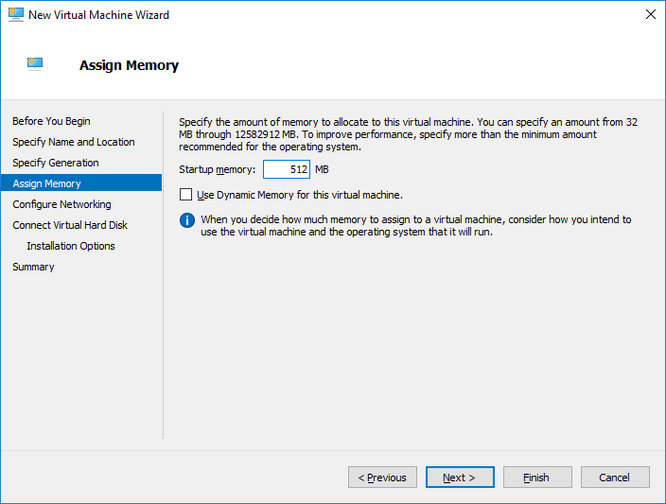

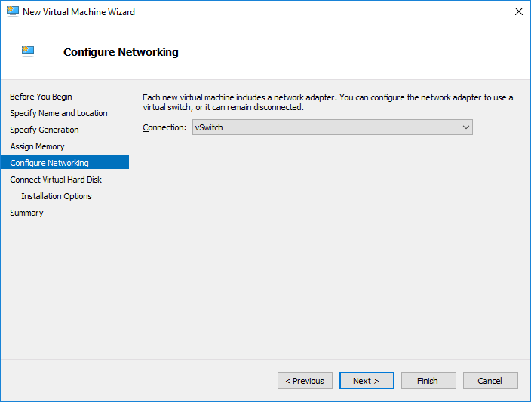

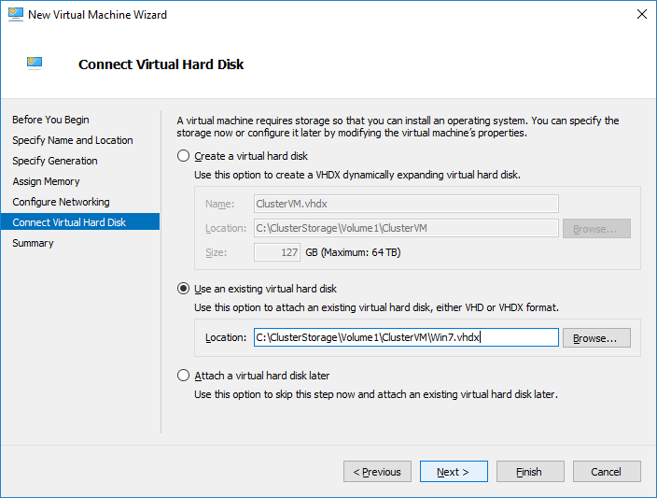

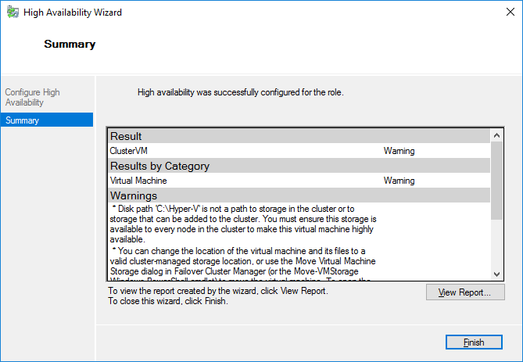

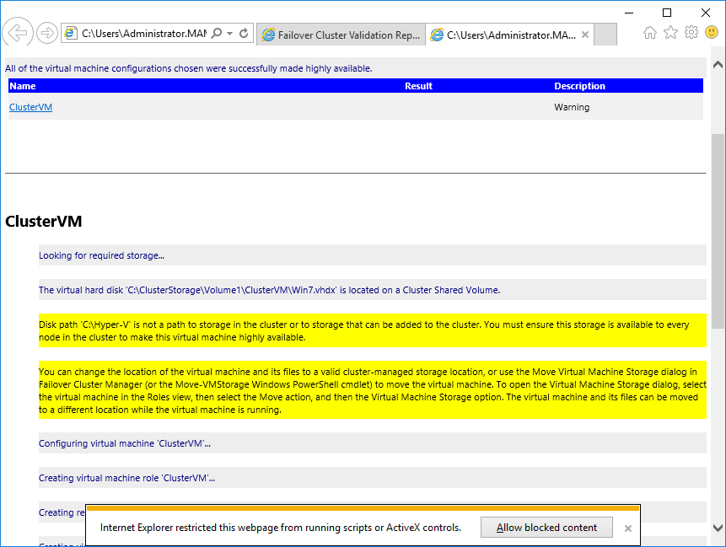

- Connect to the **ClusterVM** and start it.

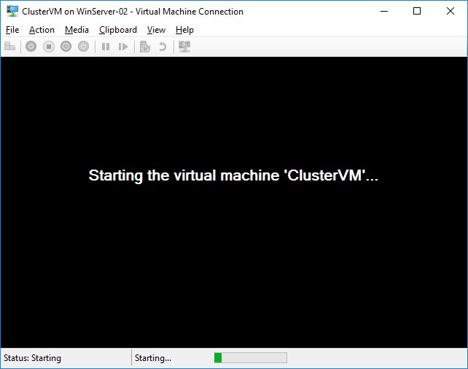

**Step 6. Perform a Live Migration for the Virtual Machine**

- On **WinServer-01**, in **Failover Cluster Manager**, start **Live Migration** of **ClusterVM** from **WinServer-02** to **WinServer-01**

**To make it work you need to take the protected network from the network feature Advanced.**

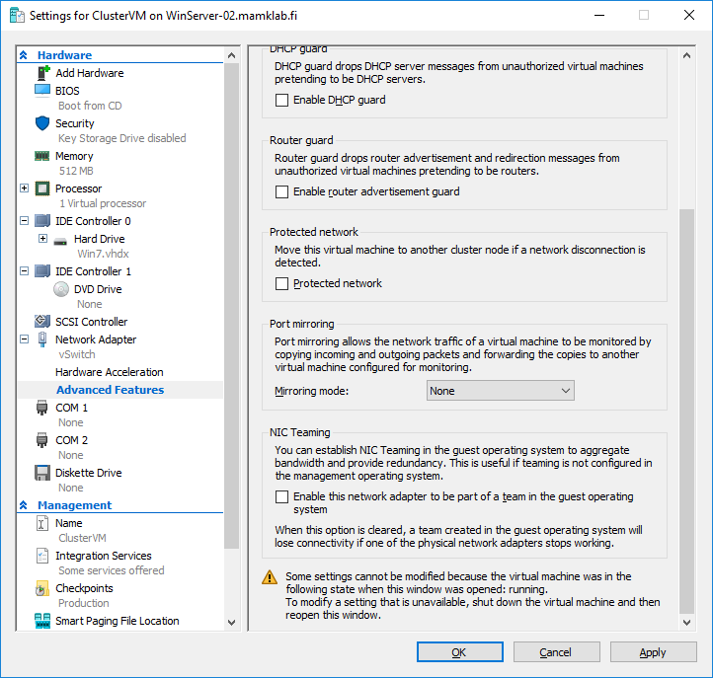

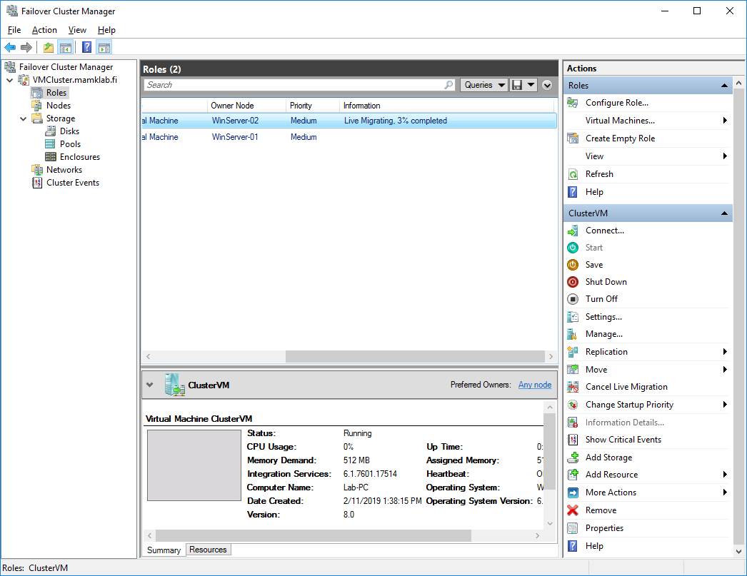

o Make sure that the virtual computer is available during the migration process.

o Notice that the live migration is now much faster than in the lab2 (where you did shared-nothing live migration).

- Open **Hyper-V Manager** (right-click **ClusterVM** and select **Manage**) and ensure that the VM has moved to **WinServer-01**.

o Also verify that the **Summary** information shows that the VM is clustered.

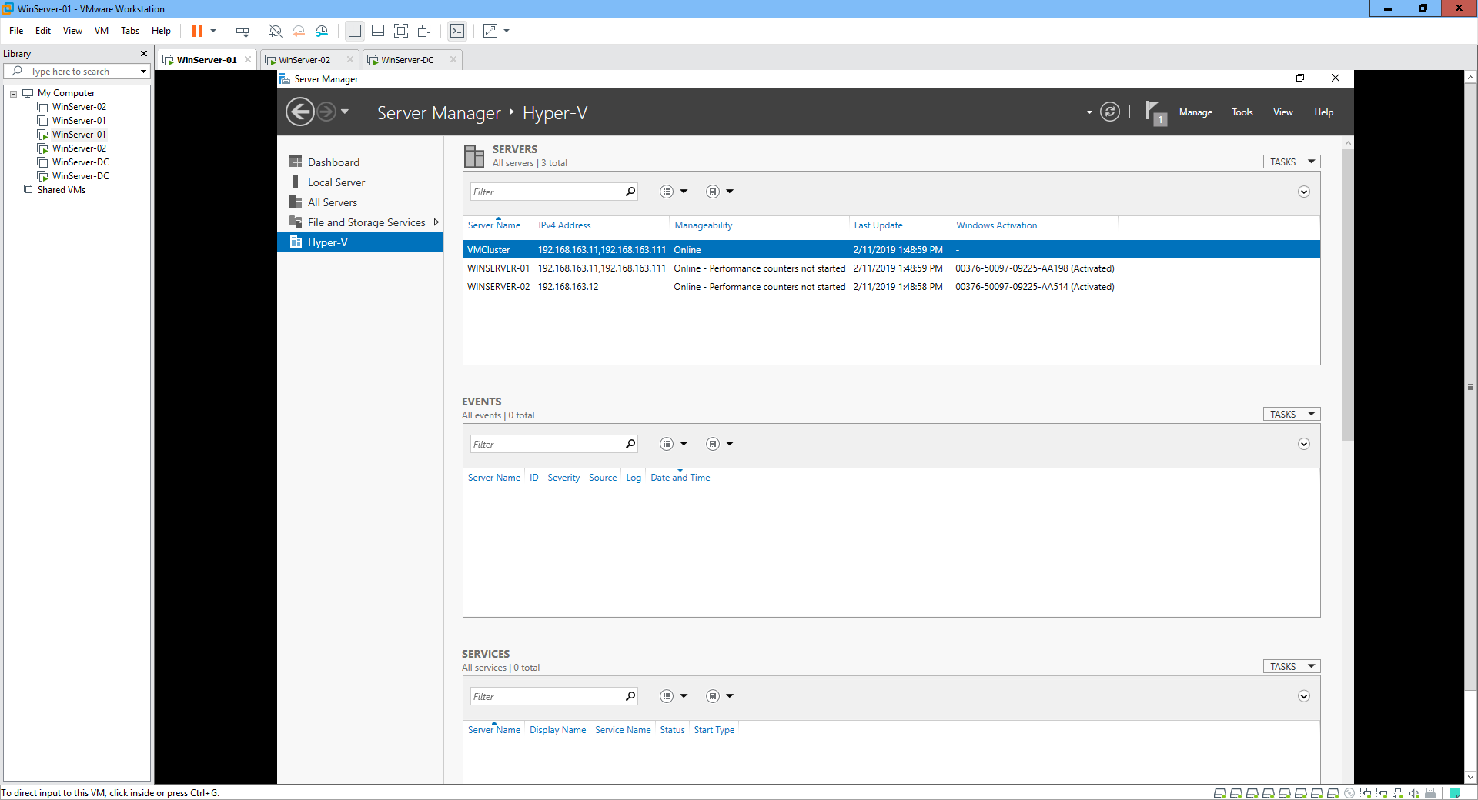

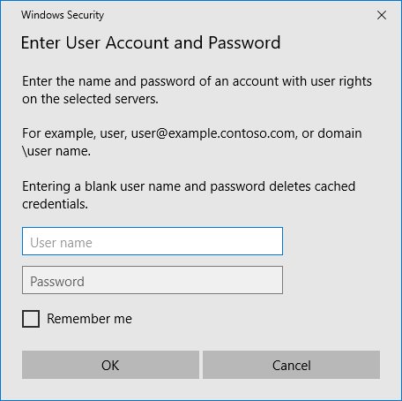

**Step 7. Simulate a Planned Server Maintenance of WinServer-02 in the Cluster**

- On **WinServer-01**, in **Failover Cluster Manager**, live migrate **ClusterVM** back to **WinServer-02**

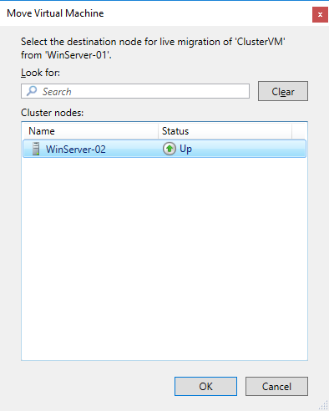

o Go to **WinServer-02** to ensure with **Hyper-V Manager** that the VM is now running there.

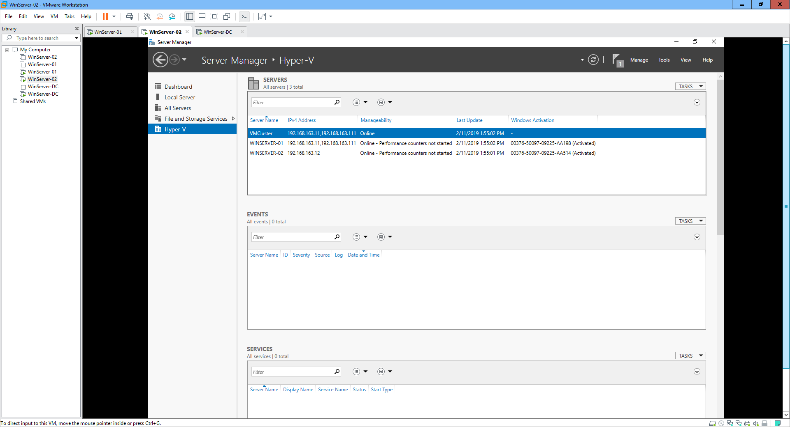

- In **WinServer-01**, expand the **Nodes** and investigate the information you can find on the servers.





- Right click on **WinServer-02** and select **Pause** → **Drain Roles**. This changes the **WinServer-02** status to **Draining** and automatically migrates all virtual machines running on **WinServer-02** to the other servers (go to the Roles page and see that the live migration automatically happens).

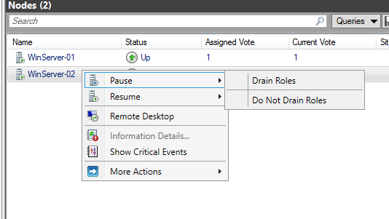



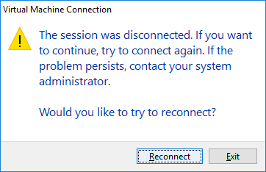

- When ready, the **WinServer-02** status should now be **Paused** and the server could be safely turned off for maintenance.

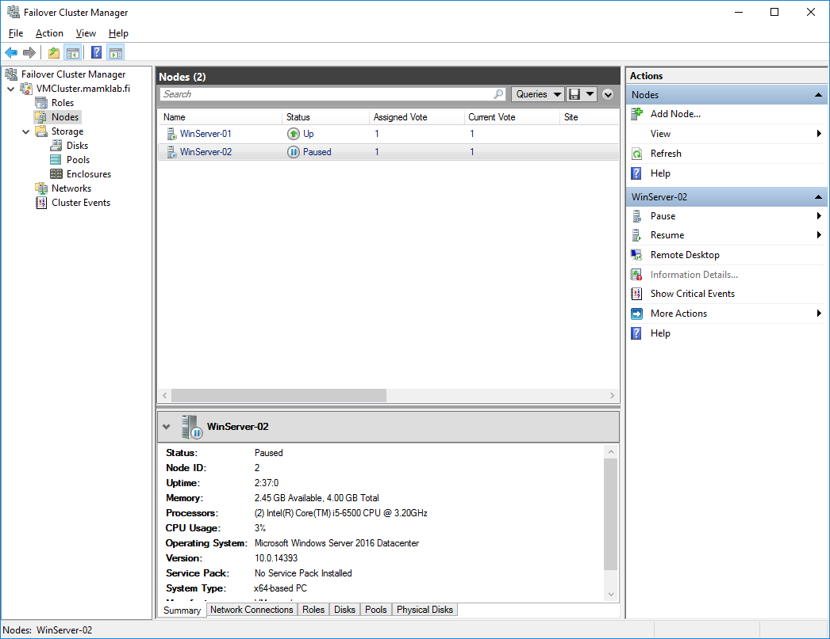

- Get the **WinServer-02** back to the cluster by right clicking **WinServer-02** and selecting **Resume** → **Fail Roles Back**. This will re-join the **WinServer-02** to the cluster and migrate the VMs back (if you just would like to re-join to the cluster without migrating the VMs, you would have selected Do Not Fail Roles Back).

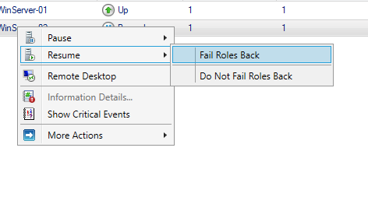

**Step 8. Simulate a Server Failure in the Cluster**

- On **WinServer-01**, in **Failover Cluster Manager**, change to the **Roles** page and verify that the **ClusterVM** is running on **WinServer-02**.

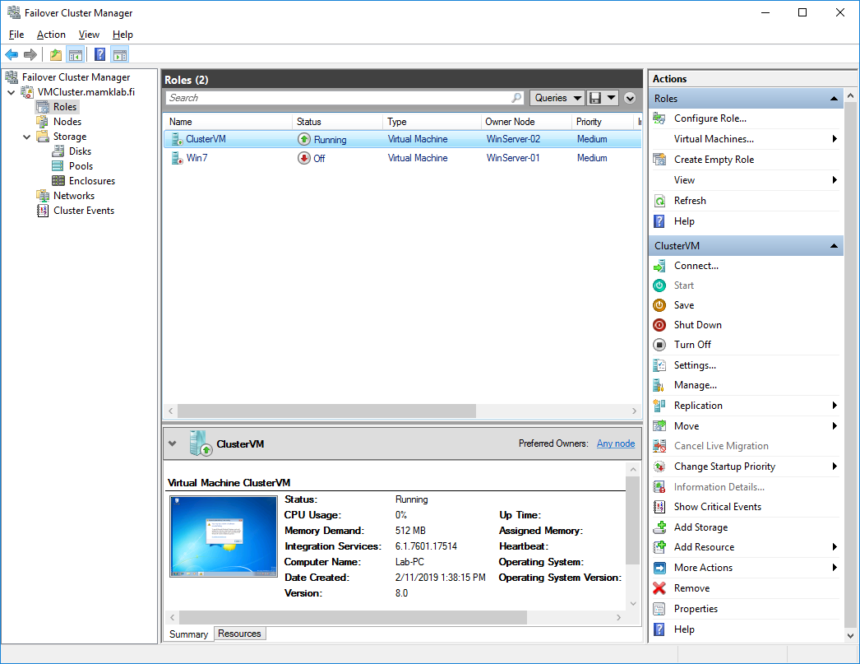

- Reboot **WinServer-02**, and watch in the **WinServer-01**’s **Failover Cluster Manager** that the **ClusterVM** automatically migrates to **WinServer-01** before the **WinServer-02** reboots. In the Nodes page, you can see that **WinServer-02** is down for some time but automatically joins back to the cluster when the reboot is complete.

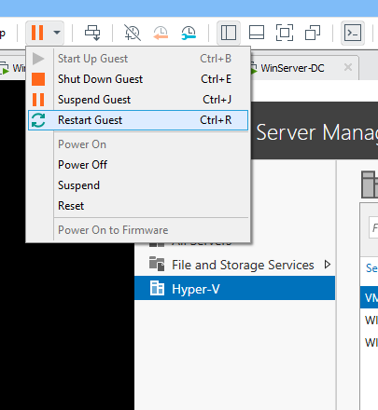

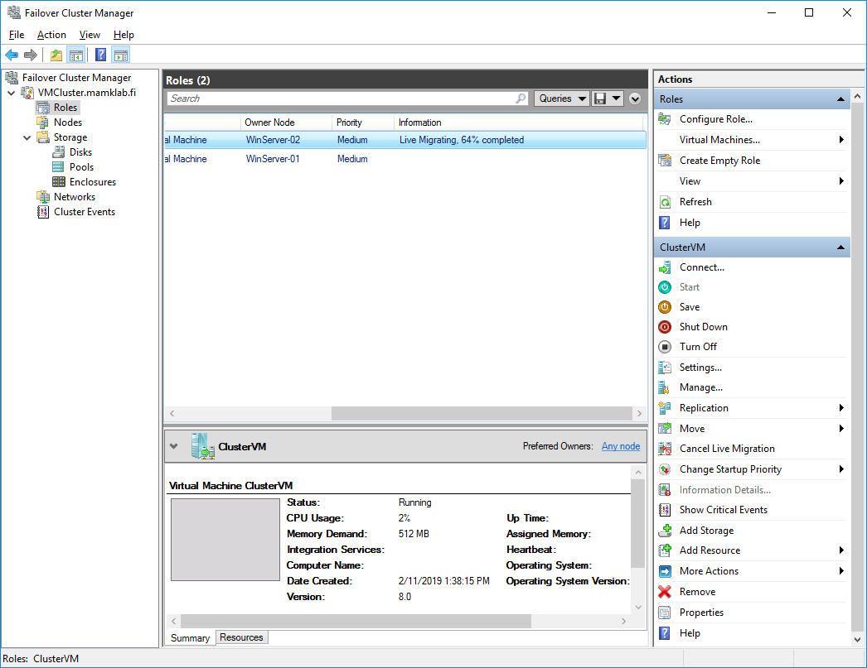

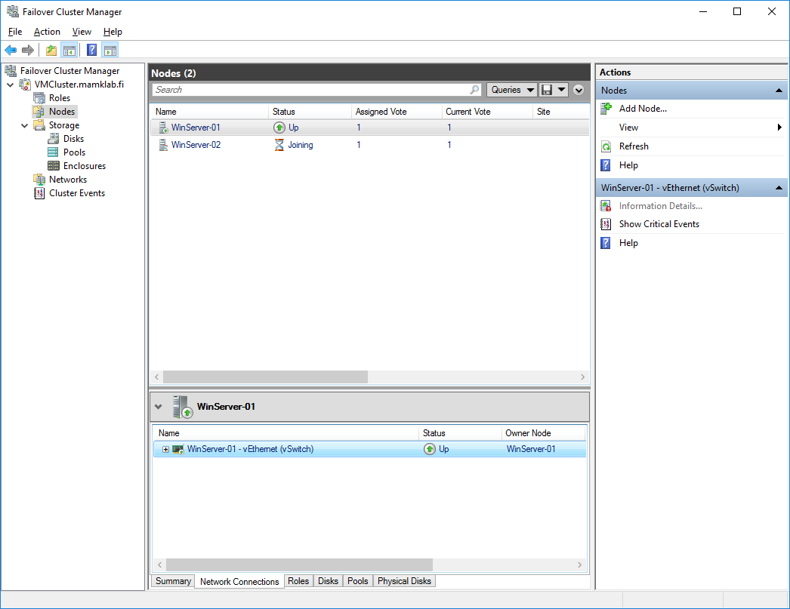

- In case you have time, you can also simulate bigger problems of a cluster node. For example disconnect a node from the network or turn a node off. However, it is also very easy to break the cluster configurations with this kind of tests, so don’t experiment with them before you have done everything else…

Finally, describe **in your report** your personal experiences about doing the lab and your experiences of working with the Hyper-V virtualization tools.

A: Hyper -V integration services is a suite of utilities in Microsoft Hyper-V designed to enhance the performance of a virtual machine’s guest operating system. It optimizes the drivers of the virtual environments to provide end users with the best possible user experience. The suite improves virtual machine management by replacing generic operation system driver files .